Prokaryotes and Eukaryotes
I CAN compare types of cells and describe the discovery of cells.
Name P.______

Prokaryotes &
Eukaryotes
Eukaryotes

Prokaryotes

1. Place two labels on each picture describing its cell type choosing from these words:
eukaryote, prokaryote, animal, plant, bacteria

2. Choosing from the following words, explain in note form one or two characteristics that identifies this cell.
nucleus, no nucleus, cell wall, no cell wall
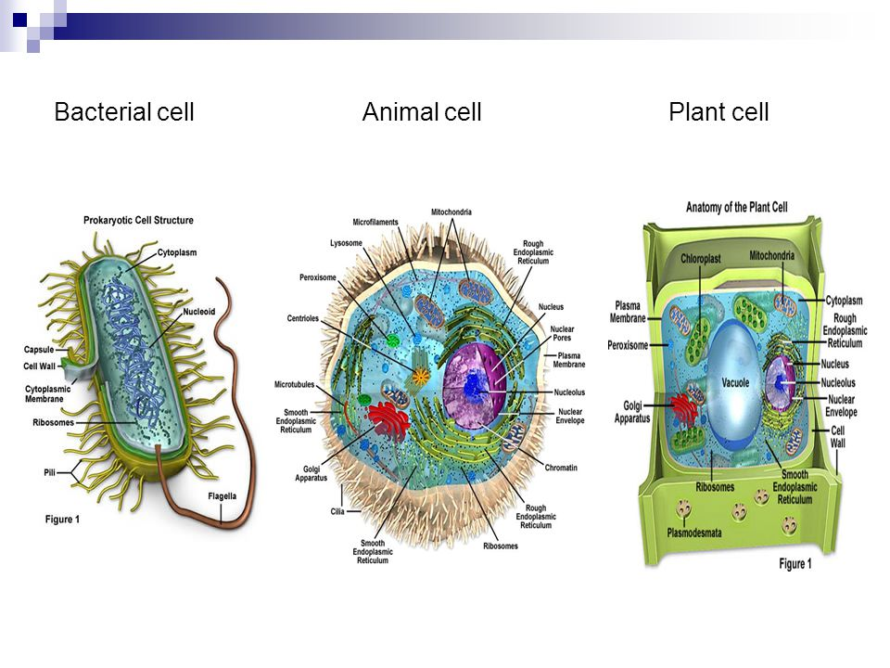

Label: __________________________ __________________________________ ________________________________

__________________________ ___________________________________ ________________________________

Explain: __________________________ ___________________________________ ________________________________

___________________________________ _________________________________

