Diffusion Lab—if you were absent:

Read through the background information.

Read through the procedures of how to set up the lab.

Do you think the baggie will choose (be selectively permeable to) only the corn starch to move out of the baggie?
If so, fill out your hypothesis as . . . stay white.
Do you think the baggie will choose (be selectively permeable to) only the iodine to move into the baggie?
If so, fill out your hypothesis as . . . turn purple.

Fill out materials: plastic baggie, pipette, corn starch, spoon, iodine, twist tie, 250 ml beaker water.

This is a picture of the setup of the beaker of iodine with a baggie of corn starch set inside the beaker.
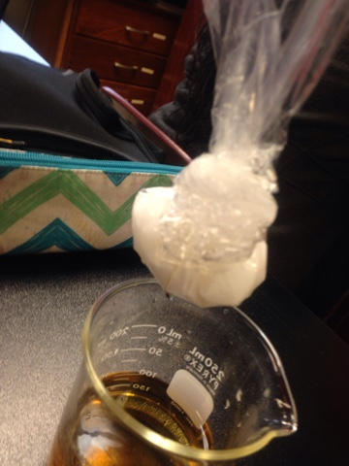
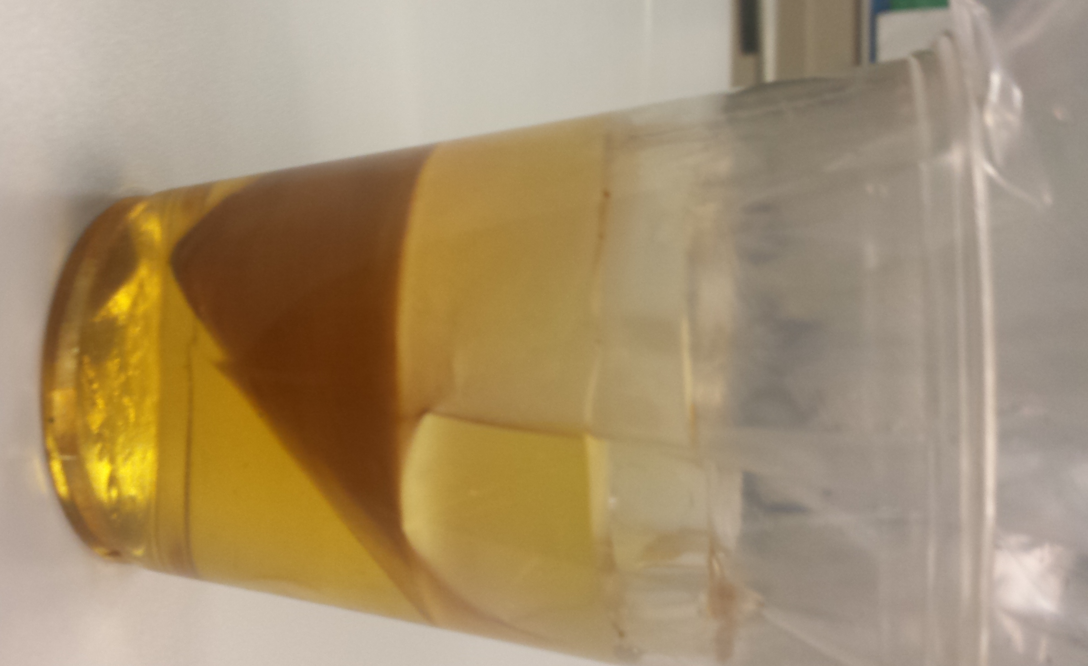

Baggie of cornstarch/water

Iodine/water

After 15 minutes—the cornstarch in the baggie turned purple and the iodine in the beaker stayed the same color (yellow-orange)
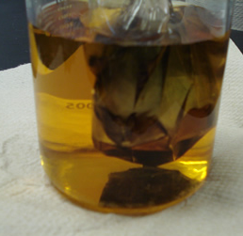

Now complete the Questions on the back of the lab paper.

