Name ____________________

I CAN explain how materials move in and out of a cell.

Period____Date____________

CELL TRANSPORT REVIEW

CHAPTER 4 Section 1

**Match the definition on the left with the term on the right.**

1. _____ release of wastes or cell products from inside to outside a cell
2. diffusion
3. dynamic equilibrium
4. exocytosis
5. osmosis
6. _____ diffusion of water molecules through a selectively permeable

membrane

1. _____ continuous movement of particles but no overall change in

concentration

1. _____ movement of particles from an area of higher concentration to one

of lower concentration

**In the space at the left, write true if the statement is true. If the statement is false, change the italicized term to make the statement true. Write this answer in the blank provided.**

_______________ 5. In *passive transport*, the movement of particles across a protein doorways requires energy.

_______________ 6. *Endocytosis* is a process by which a cell membrane surrounds and takes in material from

the environment.

_______________ 7. A membrane that allows only some materials to pass through shows *selective permeability.*

**Circle the word or phrase that best completes the statement or answers the question.**

8. The structure most responsible for maintaining cell ***homeostasis*** is the

**cytoplasm cell wall mitochondria cell membrane**

9. A cell membrane is made up of a(n)

**cholesterol layer enzyme layer lipid bilayer protein layer**

10. Which of the following uses energy?

**diffusion endocytosis osmosis**

11. Diffusion continues until

**equilibrium is reached turgor pressure is reached one side has more**

12. If a cell is placed in salt water, water leaves the cell by

**osmosis diffusion active transport phagocytosis**

13. A cell moves particles from a region of lesser concentration to a region of higher concentration by

**diffusion osmosis passive transport active transport**

Identify each image as: **diffusion**, **osmosis**, **passive transport, active transport**,

**exocytosis** or **endocytosis**.

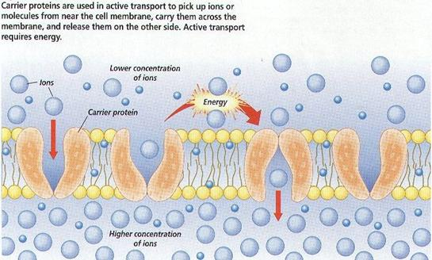

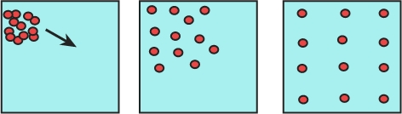

14. ________________________ 15. ________________________

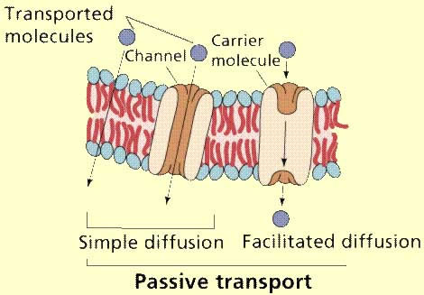



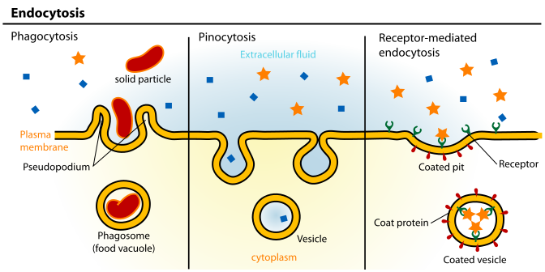



16.. _________________________ 17. _____________________

**water molecules**

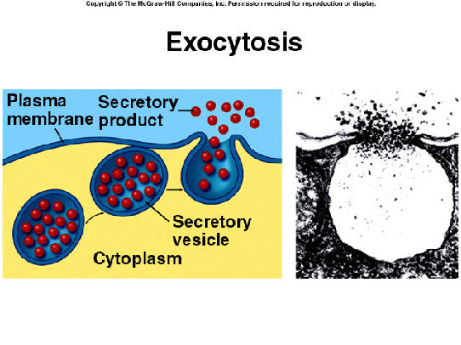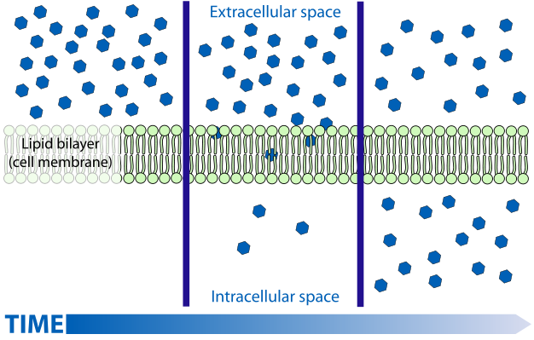

18. ______________________ 19. ____________________

20. Describe ***diffusion***:

* Moves things into/out of the cell (circle one or both!)
* Moves from high-to-low/low-to-high concentration(circle one)
* For large/small molecules (circle one or both!)
* Uses/does not use protein doorway (circle one)

21. Describe ***osmosis***:

* Moves things into/out of the cell (circle one or both!)
* Moves from high-to-low/low-to-high concentration (circle one)
* For large/small molecules (circle one or both!)
* Uses/does not use protein doorway (circle one)

22. Describe ***passive transport:***

* Moves things into/out of the cell (circle one or both!)
* Moves from high-to-low/low-to-high concentration (circle one)
* For large/small molecules (circle one or both!)
* Uses/does not use protein doorway (circle one)

23. Describe ***active transport***:

* Moves things into/out of the cell (circle one or both!)
* Moves from high-to-low/low-to-high concentration (circle one)
* For large/small molecules (circle one or both!)
* Uses/does not use protein doorway (circle one)

24. Describe ***endocytosis***:

* Uses or does not use energy (circle one)
* Moves things into/out of the cell (circle one or both!)
* For large/small molecules (circle one or both!)

25. Describe ***exocytosis***:

* Uses or does not use energy (circle one)
* Moves things into/out of the cell (circle one or both!)
* For large/small molecules (circle one or both!)