Name ________________________________
MS-ESS2-1 --> Develop a model to describe the cycling of Earth's materials and the flow of energy that drives this process.
Learning Target: I CAN model how convection cycles Earth’s materials.

Period_____Date_______________________

EARTH’S INTERIOR
Topic 7 Lesson 1 pages 280-290
Page 281-282
1. Name two different methods that geologists have found to study the unseen interior of the Earth. __________________________________________________________________
_______________________________________________________________________
_______________________________________________________________________
2. Drilling holes into the Earth brings up ______________________________
and gives geologists many clues such as where ______________are formed. Also, _____________________carry rocks to the surface and gives us clues about how ___________________and __________________________. Rocks from _______________________________show evidence that they formed deep within Earth’s crust and later elevated as _____________formed.
3. Make Observations: Compare and contrast the paths
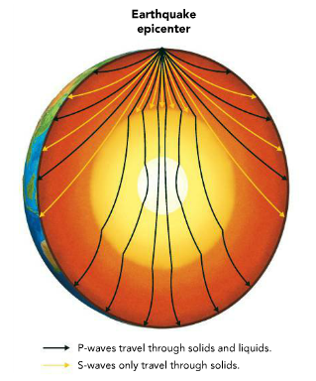
that P-waves and S-waves take through Earth. How do
you think this information helps geologists understand
Earth’s interior? FIRST-highlight the S-waves.
___________________________________________
___________________________________________
___________________________________________
___________________________________________
P-waves travel through solids
and liquids.
S-waves only travel through
solids
___________________________________________
___________________________________________
Earthquakes produce different types of seismic waves that travel through Earth. The speed of these waves and the paths they take give geologists clues about the structure of the Earth’s interior.
___________________________________________
___________________________________________
___________________________________________

Page 283
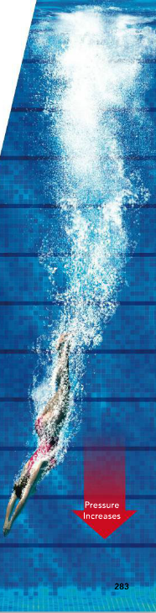
4. Compare and Contrast. How is the water in a swimming pool
similar to Earth’s interior? How is it different?
(Hint: Consider both temperature and pressure in your answer.)
___________________________________________________
___________________________________________________
___________________________________________________
___________________________________________________
___________________________________________________
At what location in the pool would the water pressure be greatest?
___________________________________________________
Page 284-285
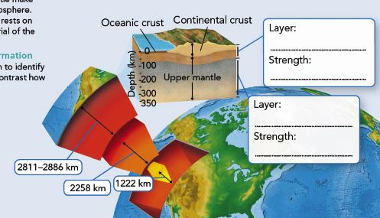
5. The crust and uppermost mantle make up the rigid lithosphere. The lithosphere rests on the softer material of the asthenosphere. Use the diagram at the left to identify the layers and contrast how rigid they are.
6. From the PPT, what is the composition, (what type of rock) is the mantle made of? _______________
7. The crust and the upper most part of the mantle is called the ____________________.

8. The part of the mantle just beneath the lithosphere that may bend like a spoon but is still solid is called the _____________________________.

9. Use the data in the table to complete this graph.
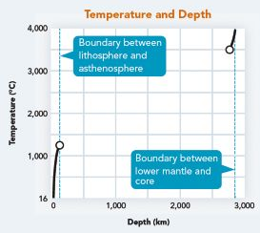
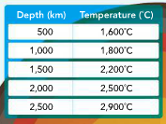

How does temperature change with
the depth in the Earth’s mantle?
___________________________
___________________________
10. Label the 4 main layers of the Earth.
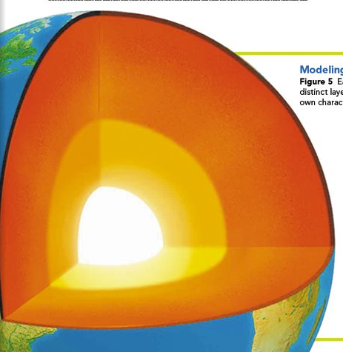

11.
