Name ________________________________
MS-ESS2-1 --> Develop a model to describe the cycling of Earth's materials and the flow of energy that drives this process.
Learning Target: I CAN model how convection cycles Earth’s materials.

Period_____Date_______________________

EARTH’S INTERIOR
Convection Currents
Topic 7 Lesson 1 pages 288-289
Page 288
1. Heat is a form of ______________that flows. It transfers from matter at a
________________temperature to matter at a ________________temperature.
2. This heat transfer in the mantle drives a process called __________________.
3. What happens to the density of water as it is heated? Name two things: ____________
and _____________________.
4. What three things set convection currents in motion.
_________________________________________________________________
_________________________________________________________________
_________________________________________________________________
5. Hot springs are common in Yellowstone National Park. Here, melted snow and rainwater seep far below the crust into the mantle, where a shallow magma chamber heats the rock of Earth’s crust. The rock heats the water to more than 200º C (392o F) and puts it under very high pressure. This superheated groundwater rises to the surface and forms pools of hot water.
Compare and Contrast: The heated water is (more or less) dense than the melted snow and rainwater. What process causes convection currents to form in a hot spring?
_________________________________________
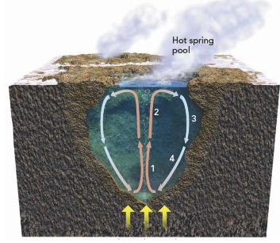
_________________________________________
_________________________________________

Page 289
6. Where does the heat come from to drive the convection currents? __________________
and ___________________________.
7. As the oceanic lithosphere cools and sinks, it drives a pattern of ____________________.
8. The cold lithosphere (sinks or rises) into the mantle (the asthenosphere), where it is (heated or cooled) and then it (sinks or rises) to the base of the lithosphere where it begins to cool again and the cycle continues.
9. One full convection cycle can take _________________of years.
10. What do convection currents produce at the Earth’s surface?______________________
11. Complete the figure below by using these terms:
hotter, colder, less dense, more dense, sinks, rises.
Temperature:_________
Density:_____________
The Rock:___________
Temperature:_________
Density:_____________
The Rock:___________
