Name____________________________
Period ___ Date ____________________

PHOTOSYNTHESIS
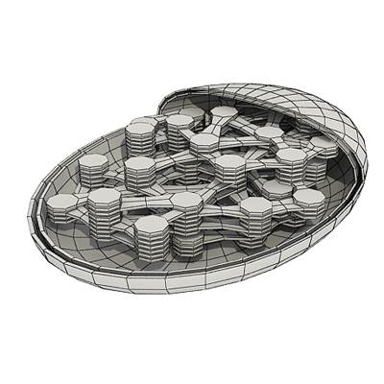
1. What kind of organisms have photosynthesis?

_____plants and algae___________

2. Where does the energy come from for photosynthesis?__sun

3. What is the main product of photosynthesis? __glucose_____

4. What useful gas is released to the air during photosynthesis? _____oxygen__________

GIVE A CHEMICAL DEFINITION OF PHOTOSYNTHESIS using these chemical element symbols C H O which stand for Carbon, Hydrogen, and Oxygen.

7. light
energy
9.
6CO₂ + 6H₂O + C₆H₁₂O₆ + 6O₂
Reactants PRODUCTS

10. In which plant part does photosynthesis take place? _ leaves_________
(The answer is NOT chloroplasts.)

11. What do chloroplasts do? _make ______glucose________

12. What happens to the energy from the sun? Light energy is transformed into chemical energy.________________________________________________________

13-17. Sketch a plant and place arrows in the sketch showing the photosynthesis cycle. Label arrows with the chemical symbols you used in 5-9 above.
H₂O
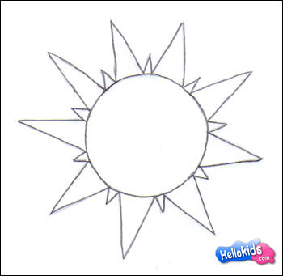
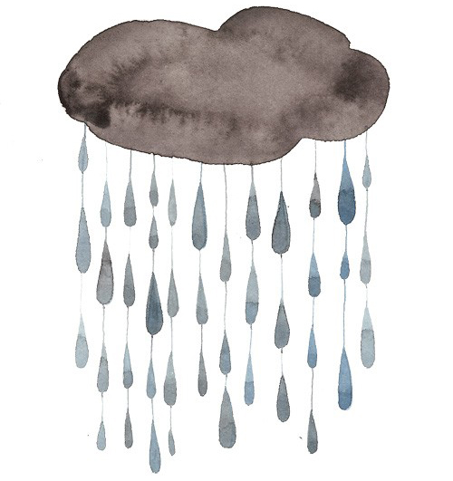

light energy

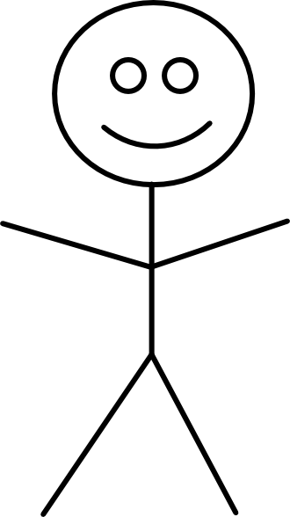
CO₂
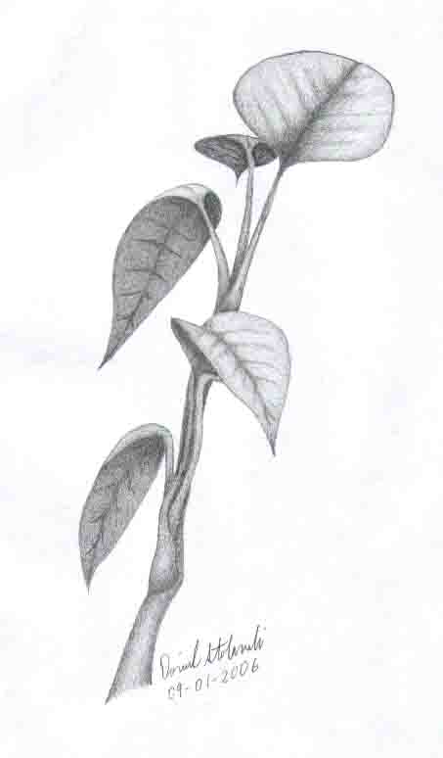

O₂
C₆H₁₂O₆ and

Name____________________________
Period ___ Date ____________________

CELL RESPIRATION
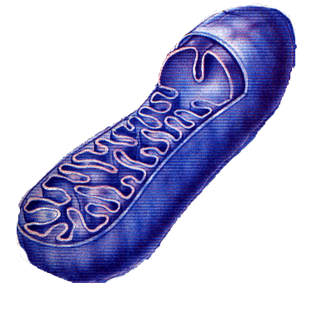
1. Cell respiration takes place in what organelle? __mitochondrion

2. Cell respiration requires what gas to be present? oxygen____

3. 3. Cell respiration uses what food? ___glucose from food we eat

4. Cell respiration produces what waste and side product? __CO₂ + H₂O___________

5. Cell respiration accomplishes what (main product)? ____energy--ATP____________

GIVE A CHEMICAL DEFINITION OF CELL RESPIRATION using these chemical element symbols C H O which stand for Carbon, Hydrogen, and Oxygen.

C₆H₁₂O₆ + 6O₂ 6CO₂ + 6H₂O + ATP (energy)
PRODUCTS
REACTANTS

10. Why do you need plants for energy? Plants give us O2 and sugar to convert to energy.

11-15. Sketch a stick figure and place arrows in the sketch showing the cellular respiration cycle. Label the arrows with the chemical symbols you used in 5-9 above.
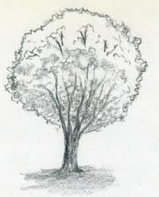
O₂

H₂O
CO₂
ATP (energy)

C₆H₁₂O₆
