Name____________________________
I CAN explain photosynthesis and cellular respiration.

Period ___ Date ____________________
STUDY GUIDE for Chapter 4 Section 2—Cell Energy
- complete this study guide
- study—this study guide
- Make and study flash cards

If you do not receive a passing grade
on this test, in order to retake it you are
required to: have your parent
sign this study guide.
My child had completed this study guide, studied, and is ready to retake this test.
_________________________________
parent signature

PHOTOSYNTHESIS
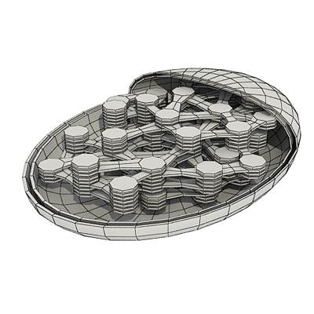

1. What kind of organisms have photosynthesis?
_______________________________________

2. Where does the energy come from for photosynthesis?_____

3. What is the photosynthesis all about –the MAIN product? _____________________

4. What useful gas is released to the air during photosynthesis? ___________________

GIVE A CHEMICAL DEFINITION OF PHOTOSYNTHESIS using these chemical element symbols C H O which stand for Carbon, Hydrogen, and Oxygen.

6.
9.
8.
5.
7.
9.
+ + +
REACTANTS
PRODUCT
PRODUCT

10. In which plant part does photosynthesis take place? _________________
(The answer is NOT chloroplasts.)

11. What do chloroplasts do? _make __________________

12. What happens to the energy from the sun?_________________________________

__________________________________________________________________

13. What happens to the light energy during photosynthesis—is made in to an electrical energy or chemical energy?________________________

14-18. Sketch a plant and place arrows in the sketch showing the photosynthesis cycle. Label arrows with the chemical symbols you used in 5-9 above.

Name____________________________
I CAN explain photosynthesis and cellular respiration.

Period ___ Date ____________________

CELL RESPIRATION
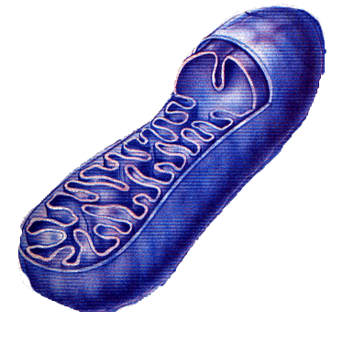
19. Cell respiration takes place in what organelle? _____________

20. Cell respiration requires what gas to be present? __________

21. Cell respiration uses what food? ________________

22. Cell respiration produces what waste and side product? _________________

23. Cell respiration accomplishes what (main product)? ______________________

GIVE A CHEMICAL DEFINITION OF CELL RESPIRATION using these chemical element symbols C H O which stand for Carbon, Hydrogen, and Oxygen.
25.
24.
28.
27.
26.
+ + +
P R O D U C T S
REACTANTS

29. Why do you need plants for energy?________________________________________

__________________________________________________________________

30. What color does bromothymol blue turn to when carbon dioxide is removed?__________

31. What color does bromothymol blue turn to when carbon dioxide is added?___________

32-36 Sketch a stick figure and place arrows in the sketch showing the cellular respiration cycle. Label the arrows with the chemical symbols you used in 5-9 above.

