Name ___________________________
ONLY if you do not meet proficiency on Earth’s Interior summative assessment:
to retake you must study this guide, have your parent sign below, bring me this signed Study Guide within a week of the test and schedule a time for the retake.
My child is ready to retake this test.

Parent or guardian signature
Period______Date_________________

STUDY GUIDE Earth’s Interior

Directions-Label: Oceanic Crust, Inner Core, Lithosphere, Outer Core, Lower Mantle, Asthenosphere, Upper Mantle, Continental Crust

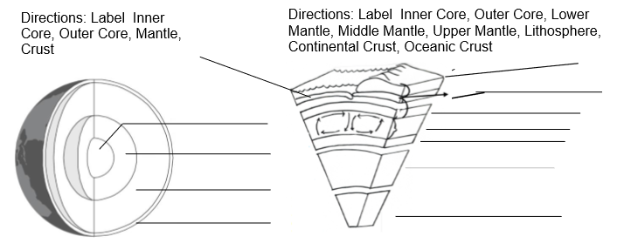
Directions-Label:
Outer Core, Crust, Inner Core, Mantle

1. Name two examples of evidence that scientists use to discover what the layers of Earth are like. ___________________________________________________________
__________________________________________________________________
2. Describe how the pressure and temperature changes if we could travel into the interior of the Earth. ________________________________________________________
__________________________________________________________________
3. Fill in the state of matter (solid or liquid) for each of the 4 main layers of the Earth.
Crust: _________________
Mantle: ___________________
Outer Core: ____________________
Inner Core: ____________________
4. In Figure 2, label the convection currents with the following words:
sinking, rising, less dense, more dense, cooler, hotter
Convection Current
Figure 2
a..____________
Figure 1
Convection Currents in the interior of the Earth.
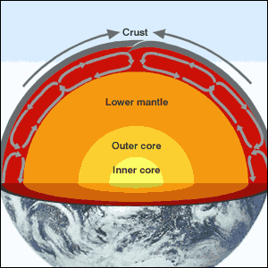

e._________dense
c._________ dense
d._________
f._______

b.________

5. What would the molecule particles look like in Figure 2a above?

What would the molecule particles look like in Figure 2b above?

6. In Figure 3 below pictures Y and Z represents rocks in the earth’s mantle.
Answer the following:
Which rock, Y. or Z., represents the most dense rock?____________________
Which rock, Y. or Z., represents the hotter rock?_______________________
Which rock, Y. or Z., would rise up into the upper part of the mantle?_______________
Y. and Z. represents rocks in the Earth’s mantle.
Y.
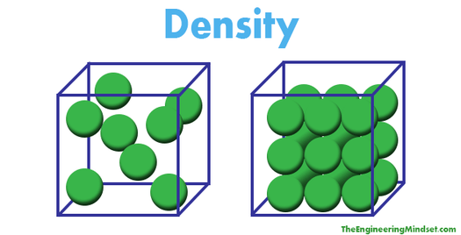
Figure 3

Z.

