Name______________________

**I CAN** explain and describe how animal & plant cells produce more cells.

Period ___Date______________

If you **do not receive a passing grade**

My child had completed this study guide, studied, and is ready to retake this test.

_________________________________

parent signature

on this test, in order to retake it you are

required to: **have your parent**

**sign this study guide.**

**DNA and the Cell Cycle**

Study Guide Cell Cycle Chapter 4 Section 3

1. How many chromosomes in the human body cell? ______________

2. How many homologous chromosomes in the human body? ________________

3. The structure (shape) of DNA is called ______________________

4. ______________________ are organized structures of DNA and proteins.

5. DNA stands for the two words: (spell correctly)______________________________.

6. The Base-Pairing Rules in DNA are: ____ to _____ and ____ to _____

7. You and a banana’s DNA have the same function and structure, so what’s the difference?

__________________________________________________________________

__________________________________________________________________

8. What is a nucleotide made of? ___________________________________________

__________________________________________________________________

9. Circle the error in the nucleotide code below.

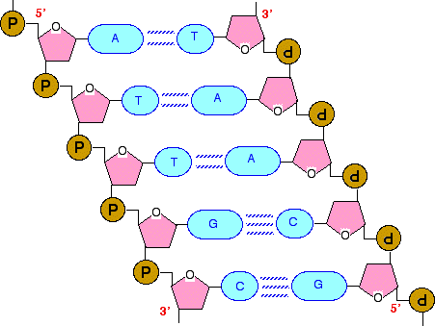



T

A

10. When such an error occurs,

it is known as a ____________.

T

G

g

T

A

11. In the article we read in ScienceWorld called “The Immortal Woman,” explain what HeLa cells are.___________________________________________________________

_________________________________________________________________

12. The second, third, fourth, and fifth steps of the cell cycle ALL TOGETHER are called ________________________

***Identify each step of the cell cycle. THESE WILL NOT BE IN ORDER ON THE TEST!***

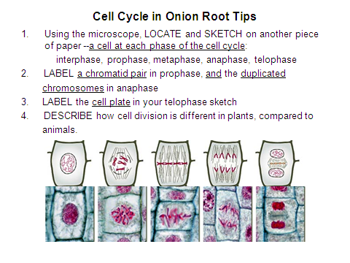





13. _________________ 14,________________ 15. ___________________

cell plate





16. ____________________ 17. ___________________

**Mastery—You do not need to answer these questions on the Study Guide.**

**This is just to let you know what you need to study to receive Mastery on the test.**

* Know how to draw a simple DNA model with four nucleotide base pairs AND label each nucleotide.
* Be able to explain, with examples, why cells need to produce more cells.