Name _____________________________
ECOLOGY STUDY GUIDE
P. ___Date_________________________

Label numbered items as abiotic or biotic.
Label lettered items as: organism, population, community.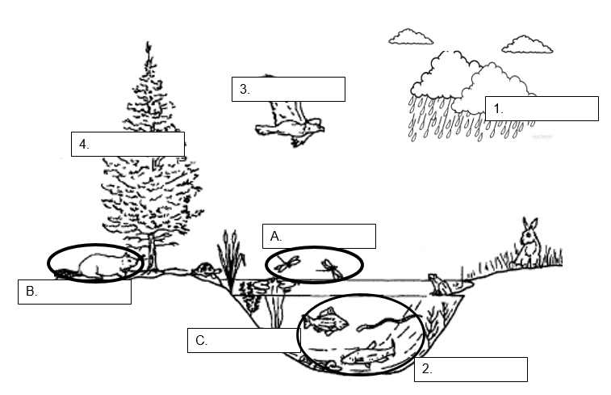
The water
Not the water
5. Explain the difference between an organism’s habitat and its niche.______________________
________________________________________________________________________________
________________________________________________________________________________
6. a. Write two examples of a Red Wolf’s habitat:________________________________________
b. Write two examples of a Red Wolf’s niche: _________________________________________
Fill in the blank squares to complete the graphic organizer with the name, description, example, and any other helpful information. In the “example” enter
Symbiosis
Close relationship between two organisms where at least one benefits

7. Mutualism
9.
8.

One benefits, the other is harmed

Ex.
Ex:
Ex: A bird builds its nest in a tree.
Bird
Tree

Use the food web to answer the questions.

FIGURE 2
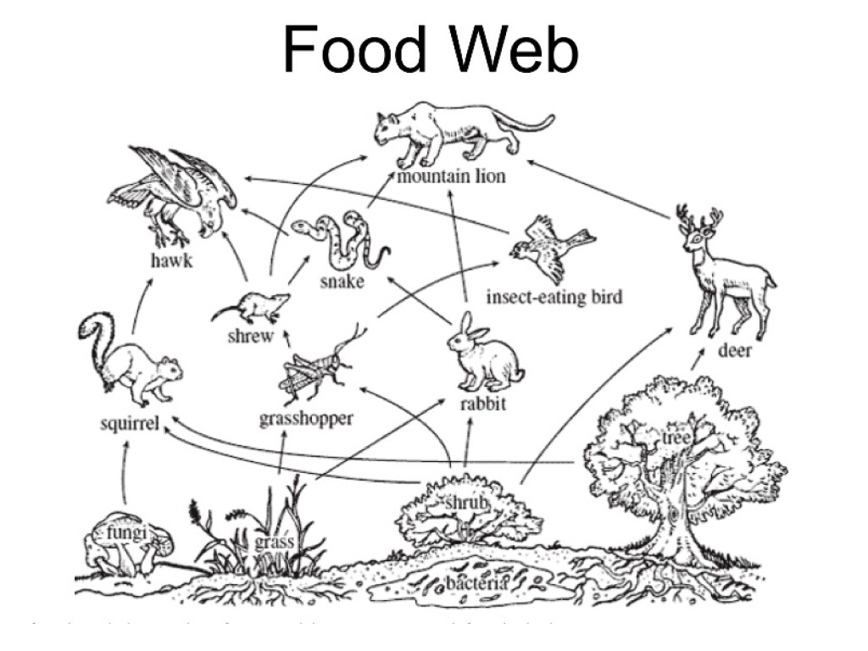

10. What does the shrew eat for energy?_______________________________
11. What is the primary source of energy for this food web?____________________
12. The mountain lion would compete for the snake with what other organism?________________
13. What would happen to the mountain lion population if the deer and rabbit were removed from this ecosystem? Explain._______________________________________________________________
________________________________________________________________________________
14. How would the changes in the deer and rabbit population discussed in #13 affect at least two other organisms in the ecosystem? Explain._____________________________________________
________________________________________________________________________________
________________________________________________________________________________
________________________________________________________________________________

Energy Pyramid Directions: Choose a word from the list below to fill in the name of each level. Then write the name of one organism from the above food web in Figure 2 that belongs on that level.
Word list: primary consumer, producers, secondary consumer, tertiary consumer

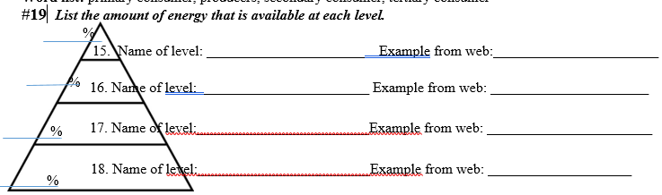

Use Figure 3 to answer the following questions.
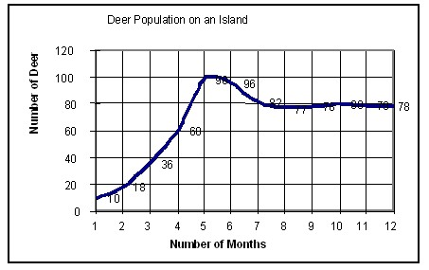
FIGURE 3

20. In month 7, the deer population reached
_______________________________.
(not a number)

21. List two possible limiting factors causing
The population of deer to level-off.
_______________________________
_______________________________

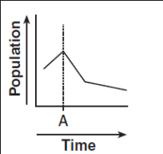
22. Continue the line on the graph to show what most likely would happen to a population of a certain animal if a new predator were introduced at time ‘A’.
Mastery Questions: You will need to:
1. analyze a food web based on changes in populations at first and over time and include in your explanation the words “carrying capacity.”

2. create and label a food web.

3. interpret a population graph that includes two different prey populations and one predator population.

FIGURE 4

