Name ____________________________

You must show me this completed study guide BEFORE retaking the test.

Period_____Date___________________

**STUDY GUIDE** for Natural Selection/Change Over Time CHAPTER 7

1. Solidified remains of once-living things are called ______________________.

Figure 1

2. In figure 1, the items from the longest time ago are in

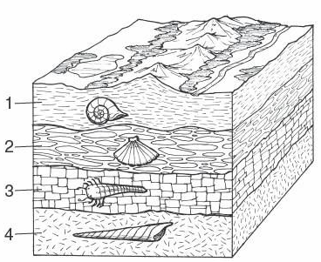

layer number ______.

3. The similarities in the fore-limb bones of humans, cats, whales and bats, see Figure 2 support the theory of evolution by inferring that animals that are different such as these, are all_______________________________________________________.



Figure 2

4. If black bats and white bats can interbred they are considered to be the same _____________.

5. In Figure 3, the pelvic and femur bones in the whale are an example of Figure 3

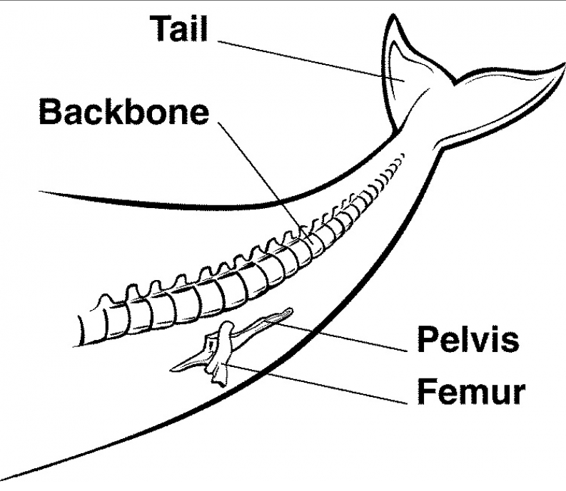

__________________ _____________________

which means something that may have been useful in the past,

but not in this organism.

6. The dark moth population increased because pollution altered its environment. This change in color of this population that helped it survive in its environment is called a (an)______________________.

7. ___________________was a naturalist who came up with an explanation for his observations of Natural Selection.

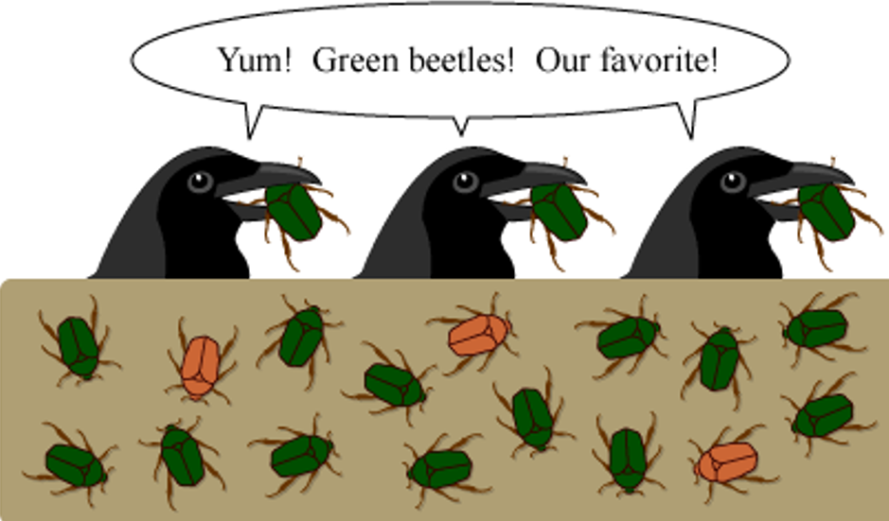

8. Identify the 4 steps in this picture

a. overproduction:__________________

_____________________________

b. genetic variation: _______________

____________________________

c. struggle to survive:__________________________________________________

________________________________________________________________

d. successful reproduction: ______________________________________________

________________________________________________________________

9. The variations Darwin observed among finches were caused by changes in a gene called

___________________.

10. Review your “Speciation” picture and know:

a. What causes the squirrels to be different?_______________ ______________

b. In picture #4, if they cannot interbreed, are they considered to be the same or different species? _____________

c. If the squirrels could interbred in picture 1, but by picture 4 they are no longer able to interbred, this is called ____________________.

d. In picture two, the rise of the water level caused the first step of speciation which is called ________________________.