Name __________________________
Period____Date__________________

What you need to know for PROFICIENCY on the
CONSERVATION OF MASS summative assessment.

Place a check mark by each statement that you know how to do correctly.

I CAN

____ list the correct number of atoms of a molecule in a chemical formula.
2CaCO₃ answer: ___Ca ___C ___O

____ identify the reactants and products in a chemical equation.
2Mg + O₂ 2 MgO
__________ ___________

____ draw a model for a balanced reaction
H₂ + O₂ H₂O

____ balance a chemical equation
____Na + ___ Cl₂ ____NaCl

____ determine which model demonstrates the Law of Conservation of Matter
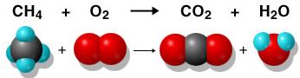
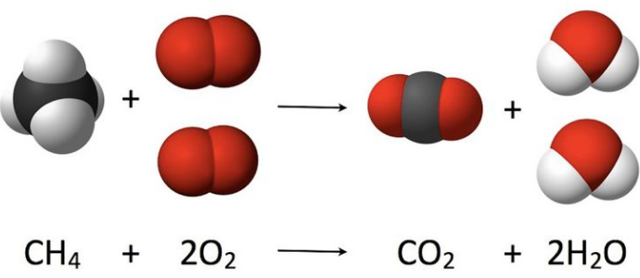

yes or no yes or no

____ state the Law of Conservation of Mass
Matter cannot be _____________or _______________.
The _______________ and ______________should be ______________ in a chemical
reaction.

____ understand how to apply the Law of Conservation of Mass to the mass before and after of a
lab.

