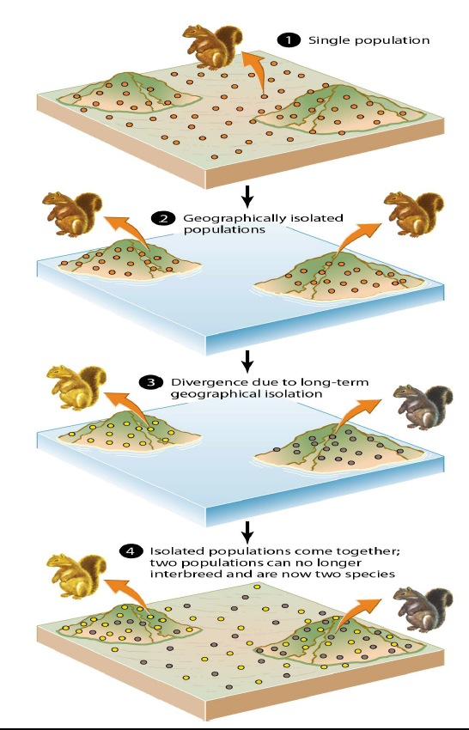

LIGHT BROWN

LIGHT BROWN

LIGHT BROWN

GRAY

LIGHT BROWN

LIGHT BROWN

**ADAPTATION**

GRAY

**SPECIATION**

**DIVISION**

**SEPARATION**