Name ________________________
I CAN explain how living things are classified based on their physical and inherited characteristics.
Write Scientific Names correctly and identify the classification
level of each of the two scientific names.

Period ___Date ________________

SCIENTIFIC NAMES

Directions: 1. Consider the pairs of names below.
2. Pick out the name which is in Latin (NOT in English) and HIGHLIGHT IT.
3. Write it in correct form on the line.
EXAMPLE:
snout butterfly - Liibytheana bachmannii
RULES: Genus and species are written in Latin
Capitalize the first letter in Genus
Underline both Genus and species

1. barn owl - tyto alba ______________________________________________
2. corvus corax - raven _____________________________________________
3. pyrota invita - blister beetle ________________________________________
4. white oak - Quercus garryana ______________________________________
5. crotalus atrox - diamondback rattlesnake _____________________________
6. locoweed - astragalus whitneyi _____________________________________
7. pinus ponderosa - ponderosa pine __________________________________
8. Danaus plexippus - monarch _______________________________________
9. American robin - turdus migratorius __________________________________
10. acer negundo - boxelder __________________________________________
11. bald eagle - Haliaeetus leucocephalus _______________________________
12. nomius pygmaeus - stink beetle ____________________________________
13. super science teacher - beckyus plankenhornax _______________________

The following are a few scientific names of common fishes and their meanings.
Let’s review together to see how the scientific names relate to the fish they describe.
For example, in Latin melano means black and curvi means curved and taenia means banded. This might be describing a fish that has a black curved band on it.

Glowlight Tetra - Hemigrammus erythrozonus –
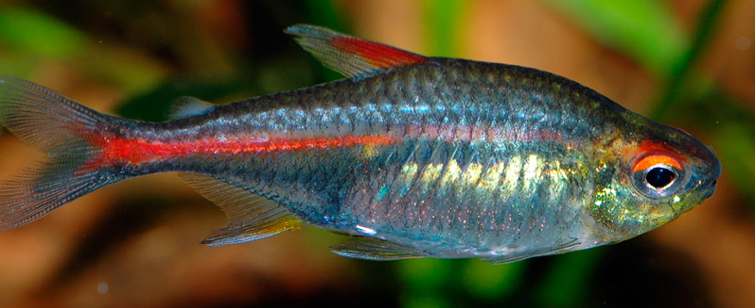
Hemi = half, grammus = mark, erythro = red, zonus = banded

Silver Shark - Balantiocheilus melanopterus
Balantio = bag, cheilus= lip,
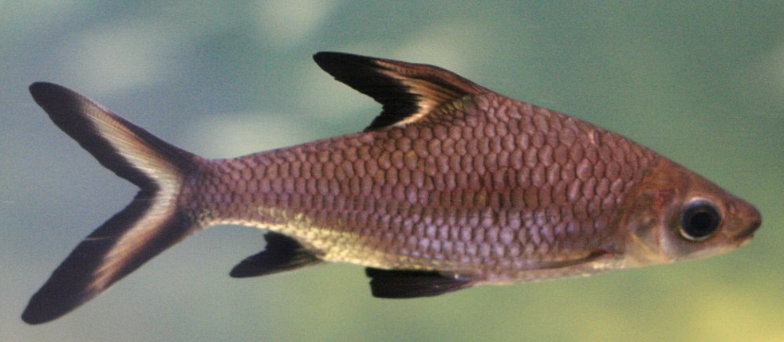
melano = black, pterus = fin)

Look at the table of Latin and Greek names to complete the Matching Exercise.
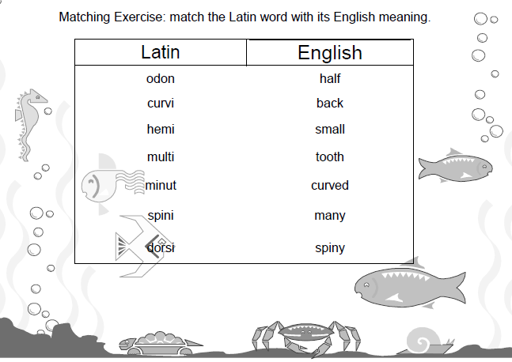

LATIN AND GREEK WORDS AND THEIR DEFINITIONS

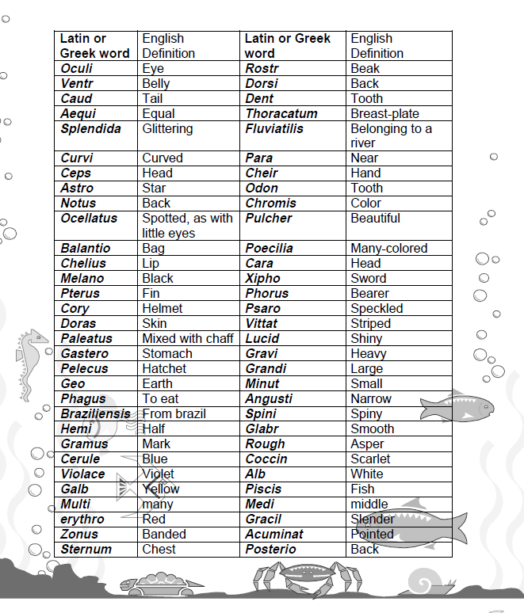

Name_____________________
Period____Date_____________

- You are an ichthyologist, a fish scientist. You are doing research deep in the Brazilian jungle in the Amazon River. You discover, what you think, is a new species of fish.
- Create a scientific name, Genus and species, for this newly discovered fish that matches the English definitions. (See table of Latin and Greek words.)
- Then illustrate (draw) the newly discovered species of fish below.

SCIENTIFIC NAME:

