Name ________________________
SCIENTIFIC NAMES PRACTICE

Period ___Date ________________

Taxonomists (classification scientists) use a very specific format and language to write scientific names so that we can always tell them apart from common names, which can be in any language.

Remember the formatting rules are:
Genus (first word) and species (second word) are written in Latin or Greek
Use a capital letter for the first letter in Genus, use lowercase for the first letter in species
Underline both Genus and species

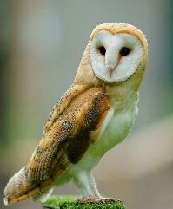
Part 1 Directions: Re-write the scientific name using the correct format for each species below. The first one is done for you

1. barn owl - tyto alba Tyto alba _______
2. raven - corvus corax _______________________________
3. blister beetle - pyrota invita _____________________________
4. white oak - Quercus garryana ______________________________

Part 2 Directions: For each species, there is a pair of names listed below. On is the scientific name and the other is a common name (though it could have other common names not listed). If the scientific name is correctly written according to the rules, write “correct” If it is incorrect, re-write the scientific name in the correct form on the line. #1 has been done for an example.

1. snout butterfly - Liibytheana bachmannii _______________________
2. pill bug or rolly polly - armadillium vulgare ______________________________
3. diamondback rattlesnake - crotalus atrox ______________________
4. locoweed - astragalus Whitneyi ____________________________
5. ponderosa pine - pinus ponderosa _________________________
6. monarch butterfly - Danaus plexippus ________________________
7. American robin - turdus migratorius _______________________
8. boxelder tree - Acer negundo _______________________________
9. bald eagle - Haliaeetus leucocephalus __________________
10. stink beetle - nomius pygmaeus ___________________________

