Name _________________________
I CAN . . . apply scientific processes to design & carry out an experiment.
List the 6 steps of the Scientific Method.
Period ___Date__________________

SCIENTIFIC METHOD STEPS

We have two of the same kind of plants in my house—one on each end
of the couch. I observed that one of the plants was growing much
better than the other.
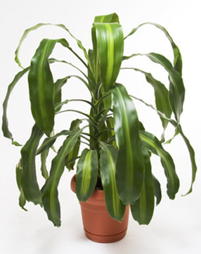
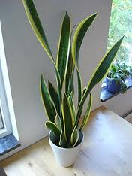
I also noticed that
every morning my
husband pours the
last of his coffee into
the plant container on
the left (the one with
the healthier plant.)

The mnemonic I’m going to use to remember the six steps of the Scientific Method is:

__________ _________ _______________ _________________ __________ & ____________

1. STEP ONE:

___________________________________________________________________________

2. STEP TWO:

___________________________________________________________________________

3. STEP THREE:

___________________________________________________________________________

4. STEP FOUR:

__________________________________________________________________________

5. STEP FIVE:

___________________________________________________________________________

6. STEP SIX:

__________________________________________________________________________

THREE GUIDELINES FOR A GOOD CONTROLLED EXPERIMENT:

1. Have a _________________ group which is used for comparison.
2. Test only _________ thing at a time.
3. Have the __________________ possible sample size.
GROUP 1 GROUP 2
PLANTS IN PLANTS WITH COFFEE GROUNDS
REGULAR SOIL ADDED TO REGULAR SOIL
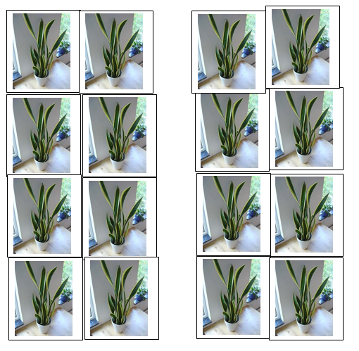

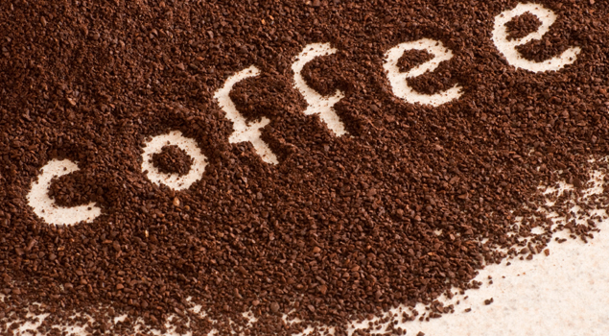

1. In the experiment above, the group that is NOT being tested—used for
comparison is called the ___________ _____________.
Circle this group above.

2. With a RED pen or highlighter, circle the ONE thing that you are testing.
This ONE thing you are testing, the thing you are changing, is also known as the
____________________ ______________________

3. What you observe during the experiment is called the _____________________
___________________. What are you observing in this experiment?
________________________________________________________________

