Name __________________________
I CAN describe the basic structure of the DNA molecule.
Period ___Date___________________
DNA Unit
Review and Directed Reading Chapter 6 Section 1a
pages 128 and 130 “What Do Genes Look Like?”
REVIEW
1. DNA is found in the ___________. (part of cell)
4._____
Label the parts of the cell below:
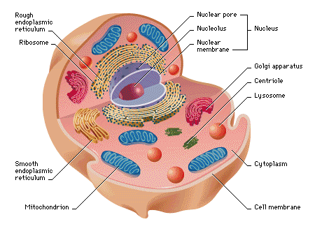
Choose from these words to label:
mitochondria
cell membrane
endoplasmic reticulum
cytoplasm
ribosome
nucleus

2. 6.

3.
the black dots

5.

6.

7.

8. __________________are linear structures made of ____________and proteins.

Directed Reading Chapter 6 Section 1a pages 128 and 130
Section 1: What Do Genes Look Like? (p. 128)
1. Where are the chromosomes found in most cells?

a. the nucleus b. the DNA

c. the genes d. the ribosomes

2. _____________________ and ______________________make up chromosomes.

The Pieces of the Puzzle (p. 128)
3. What two functions do genes give instructions for?

___________________________________________________________________________

___________________________________________________________________________

___________________________________________________________________________

4. Which of the following make up a nucleotide? (Circle ALL that apply)

a. a sugar b. a phosphate

c. a protein d. a base

5. Except for the _______________, all DNA nucleotides are identical.

6. Look at Figure 1. How do you think the nucleotides fit together in pairs?

_____ and _____ _____ and _____

***You do not need to read p. 129!!!***
DNA Structure (p. 130)

7. What part of the twisted ladder, or double helix, of DNA is made up of the nucleotide bases?
__________________________________________

8. The side rails of the twisted ladder, or double helix, is made up of what?

alternating___________________________ and _____________________ molecules

9. Look at Figure 5. What do you think happens if the bases in the DNA molecule do not pair up

correctly? ___________________

