Read p. 434-437 in the text book and fill in the definitions below.
READING SUMMARY
CHAPTER 18 SECTION 1
Name ____________________________________
P. ___Date________________________________

Organism: ________________________________________________________

Population: _______________________________________________________

Community: ______________________________________________________

Ecosystem: _______________________________________________________

Next to each example, write whether it is an organism, population, community, or ecosystem.
1. Acorn Woodpecker: _________________________

2. Acorn woodpecker population, the oak tree population, squirrel population, and the populations of grass species: _________________________

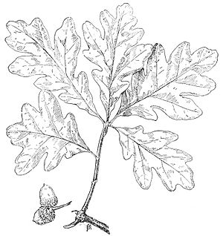
3. All the acorn woodpeckers in the forest:

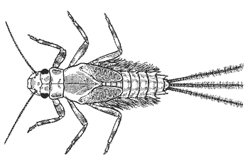
_______________________________
Using the salt-marsh example on pages 436-437 or Figure 1
name two examples of biotic and abiotic factors.

8. Biotic: __________________________________

__________________________________

9. Abiotic: ________________________________

________________________________

FIGURE 1
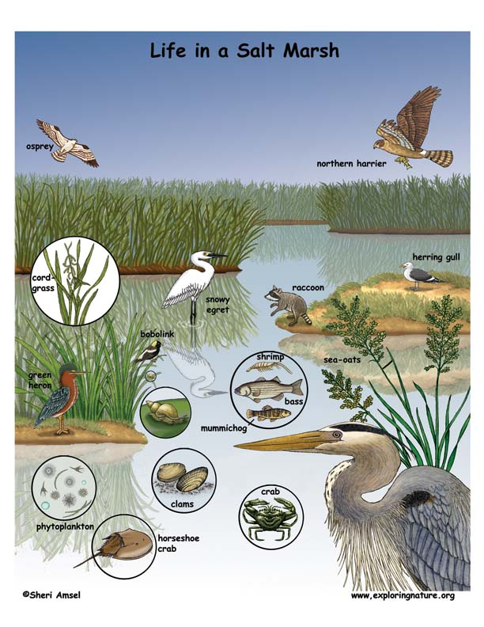
4. White Oak Tree: ________________________

5. White oak tree population, acorn woodpecker population, grasses, water, soil, and sunlight:

_______________________________

6. Mayfly nymph: _______________________

7. A creek containing Mayfly nymphs, snails, caddisflies, crawdads, boulders, pebbles and water: _______________________

