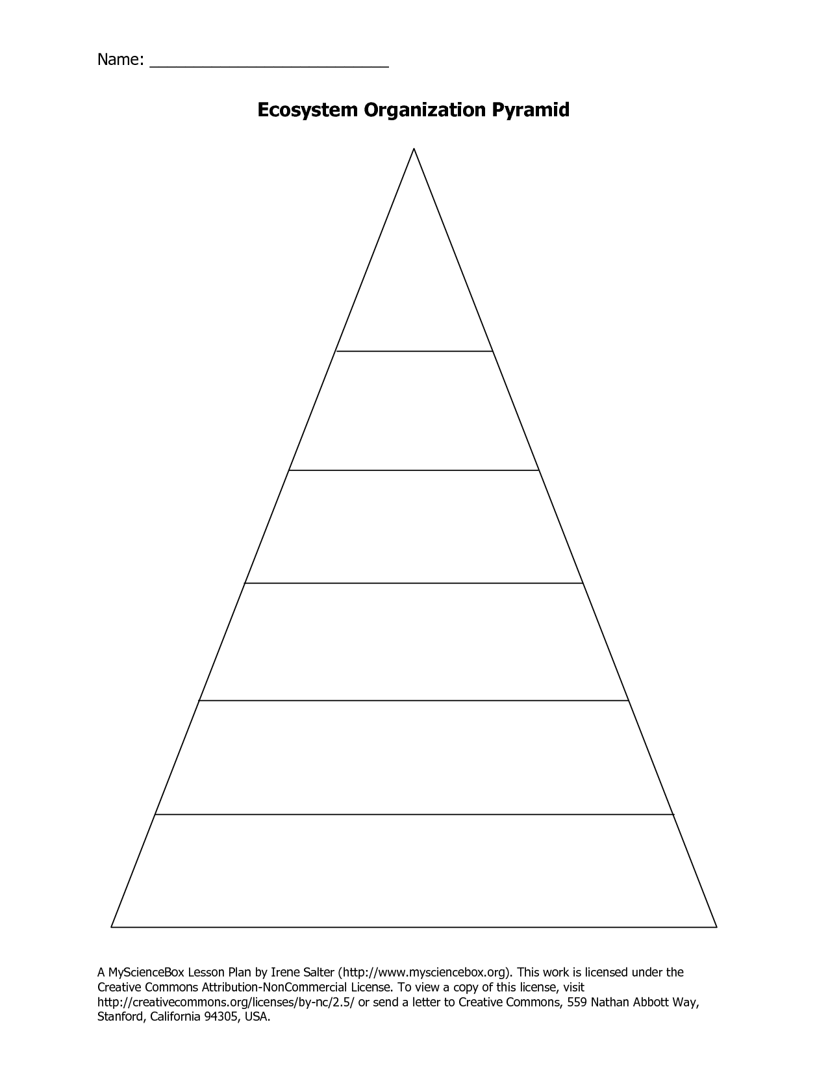

**I CAN** compare the types of cells and describe the levels of organization of life.

Recognize levels of living things

(pyramid) and how they work together

to form a living system.

Levels of Biological Organization

Name _________________________

P. _____ Date _________________