Name ___________________________
I CAN explain how inherited traits are passed from generation to generation and how they are different than learned traits.
Period____Date___________________
PUNNETT SQUARES AND DIMPLES

- Complete this worksheet after you have completed the
Directed Reading CH 5 S. 1 numbers 20-27.
- In humans, dimpled cheeks are a dominant trait, with a genotype of DD or Dd. Nondimpled cheeks are a recessive trait, with a genotype of dd.

1. Image that Parent A, with the genotype DD, has dimpled cheeks.
Parent B has the genotype dd and does not have dimpled cheeks.
The Punnett square below diagrams the cross-between
Parent A and Parent B.
Complete the Punnett square. (The first square has been done for you. You may want to refer to How to Make A Punnett square in your text.)

Parent A
FIGURE 1
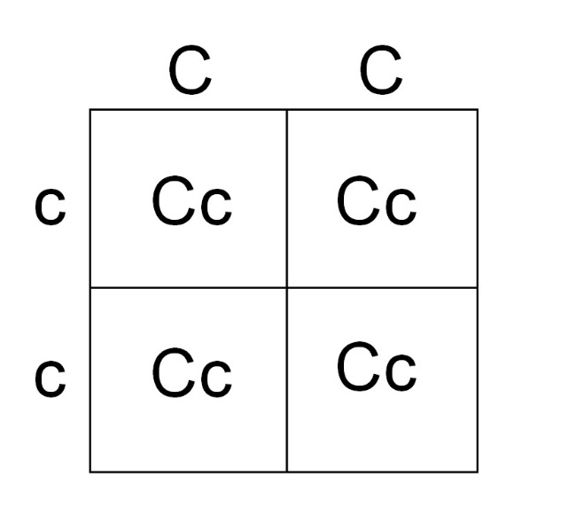
Parent B

Dd
d

d
D D
2. A Punnett square shows what genotypes are possible for the offspring of a certain cross. What genotypes are possible for the offspring of
Parent A and Parent B? _______________________

3. Each of the four squares of a Punnett square represents a 25% probability that the offspring will have that particular genotype. What is the probability that the offspring of Parent A and Parent B will have dimpled cheeks?_________

Parent X
FIGURE 2
4. Parent X, with the genotype Dd, has dimpled cheeks. Parent Y also has the genotype Dd and has dimpled cheeks as well. To find out what their offspring might look like, complete the Punnett square below.

Parent Y
D

D d

5. What is the probability that the offspring of Parent X and Parent Y will have each of the following genotypes?
DD:____________, Dd: _____________, dd: _____________

6. What is the probability that the offspring will have nondimpled cheeks?_______

7. Mary has the genotype Dd and Doug has the genotype dd. Complete the Punnett square below to find out what their offspring might look like.
Mary

FIGURE 3
Doug

7. What is the probability that the offspring of Parent X and Parent Y will have each of the following genotypes?
DD:____________, Dd: _____________, dd: _____________

8. What is the probability that the offspring will have dimpled cheeks? _______

