Name ____________________________
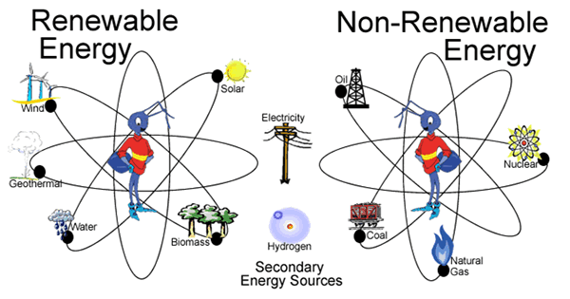
Period_____Date___________________
RENEWABLE AND
NON-RENEWABLE ENERGY RESOURCES

Assignment Instructions:
- Your job is to teach us about one renewable or non-renewable energy resource.
- Use Google Slides or Microsoft PowerPoint to CREATE A SLIDESHOW WITH AT LEAST FIVE (5) SLIDES, which explains your energy resource to the class.
- You will use some text on each of your slides, but the writing should be limited to short, key ideas, written as mostly single sentences or bullet points—not numerous, lengthy paragraphs.
- Include pictures, diagrams or other graphics to help explain your natural resource.
- The information for your slideshow must be from three sources of information:
- only one can be a Wikipedia page
- one must be from a book or magazine from the book cart, or textbooks in class
- one can be a different internet website—see next page for suggested websites
- or see handout on using ORLIS
- Use EasyBib to make an alphabetized Works Consulted list like the one below*.

What your project must include:
- Your completed Notes for Renewable or Non-renewable Energy Resource
- At least five (5) slides as described above.
- Your slideshow must answer the three MANDATORY TOPICS.
- Then choose two of the five optional topics to include in your slideshow.

MANDATORY TOPICS | PICK 2 FROM THE OPTIONAL LIST BELOW
- Description of the energy source, including how it is used and tell if it is renewable or non-renewable.  - Advantages and disadvantages of the energy source.  - Where the energy source is found and how the energy is recovered. | - Brief history of energy source  - How the energy is stored in the source and how the energy is released  - Economic impact of the energy source  - Environmental impacts of the energy source  - Future of the energy source.

*Works Consulted Examples:
Harman, Rebecca. The Earth's Resources: Renewable and Non-Renewable. Rigby, 2007.

Holt Science & Technology Earth Science. Holt, Rinehart and Winston, 2001.

“Naylor Association Management Software.” National Energy Education Development Project, Naylor Association Management Software, www.need.org/studentenergyresources.
RENEWABLE AND NON-RENEWABLE
ENERGY RESOUCES FOR SLIDESHOW

- Geothermal
- HYDROPOWER
- SOLAR ENERGY
- WIND ENERGY
- BIOMASS

- PETROLEUM
Also known as crude oil
- NATURAL GAS
- COAL
- URANIUM
- PROPANE

Helpful Websites:

Energy At A Glance - Quick Fact Sheets for Renewable and Non-renewable
http://www.need.org/studentenergyresources

U.S. Energy Information “Energy Kids” for Renewable and Non-renewable
https://www.eia.gov/kids/index.cfm

Renewable Energy:
https://www.nrel.gov/workingwithus/learning.html
https://www.eia.gov/KIDS/energy.cfm?page=renewable_home-basics

National Geographic
https://www.nationalgeographic.org/encyclopedia/renewable-energy/

Non-renewable Energy:
https://www.eia.gov/KIDS/energy.cfm?page=non-renewable_home-basics
https://www.nationalgeographic.org/encyclopedia/non-renewable-energy/

Renewable and Non Renewable Energy Sources Explained
By writer in Alternative Energy Sources, Biomass, Clean Energy, Geothermal Energy, Nuclear Power, Old Energy Solutions, Renewable Energy, Solar Power, Wind Power
http://greenplanetethics.com/wordpress/renewable-and-non-renewable-energy-sources-explained/
PROJECT GRADES:
ONE Formative Grade: Slideshow
ONE Formative Grade: Notepage
ONE Summative Assessment Grade:
Includes one general question about renewable and nonrenewable energy sources
And nine questions regarding your resource you did your research on.
Mastery Question:

Slideshow:
MASTERY:
Eight to ten slides that thoroughly and concisely teach about your resource.
Pictures, diagrams, or other graphics that directly relate to the text on the slide to help explain your resource.
Information gathered from the listed requirements and accurately cited.
EXAMPLE:
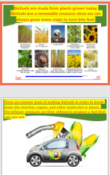
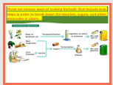
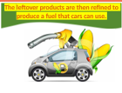

3 slides explaining ONE Mandatory Topic—thorough and concise—pictures relating to text.

ADVANCED:
Six to seven slides that concisely teach about your resource.
Pictures, diagrams, or other graphics that relate to most of the text on the slide to help explain your resource.
Information gathered from the listed requirements and accurately cited.
EXAMPLE:
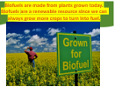
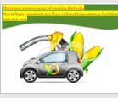

2 slides explaining ONE Mandatory Topic-concise-pictures that relate to most of the text.

MEETS:
Five slides that teach us about your resource
Pictures, diagrams, or other graphics that somewhat relate to some of the text on the slide to help explain your resource.
Information gathered from the listed requirements and accurately cited.
EXAMPLE: 1 slide that explains ONE Mandatory Topic, teaches some about your resouce, and the picture relates to some of the text to help explain your resource.
