Name__________________________
Name __________________________
Period_____Date_________________

PICK THE POLLINATOR
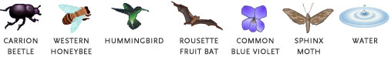

http://www.pbs.org/wgbh/nova/nature/pollination-game.html check our answers page
Flowering plants represent about one-sixth of all Earth's known living life-forms and are important to the survival of most other species. But how did these immobile organisms manage to spread so far? One answer is pollination, or plant sexual reproduction. Pollinators—typically wind, water, and animals—carry pollen from one flower to another, where fertilization takes place. Below, match seven plants with their pollinators. Learn some of the reasons why flowering plants have come to dominate the botanical world.—Rima Chaddha

Match the pollinators shown above with the plants they pollinate (below). Note there is only one correct choice for each plant. Write your answers in the space provided.
Refer to the laminated color pictures of the plants.

1. Hardy fuchsia
Attracted to the fuchsia's bright red sepals and purple petals, this pollinator can visit hundreds of flowers each day, making it very important to the plant's reproductive cycle. Fuchsia flowers hang downward and serve as an ideal food source for this pollinator by offering great quantities of nectar.
Hint: While most pollinating insects are blind to the color red, this organism sees red objects particularly well.
1. Answer: ___________________________
2. Canada goldenrod
With its bright yellow petals, abundant nectar, and protein-rich pollen, goldenrod attracts a variety of pollinators, including one of the above. This organism is equipped with "pollen baskets" on its hind legs, and it uses the goldenrod's nectar to create a
sweet, viscous liquid often prized in folk medicine as an antiseptic agent.
Hint: Farmers often utilize this easily bred organism in pollinating commercial crops such as almonds.
2. Answer: ____________________________
3. Comet orchid
Nicknamed for its appearance, the comet orchid has a milky white flower and a long "tail" consisting of a spur that holds the flower's nectar. While scentless by day, the orchid flower becomes fragrant at night, attracting this nocturnal pollinator.
Hint: Only a very specialized pollinator can reach this flower's nectar.
3. Answer: ____________________________
4. Common blue violet
The common blue violet has a variety of insect pollinators, but there is one other species that helps the plant procreate and even stretch beyond the insects' usual habitats.
Hint: The open "bud" pictured here is more important than you might think. What's going on here?
4. Answer: ____________________________
5. Wild celery
Despite its name, wild celery bears little resemblance to the leafy vegetable you buy at the grocery store. In fact, while the celery we eat depends upon insects for pollination, wild celery takes an entirely different approach to reproduction: it utilizes its natural habitat to scatter its pollen.
Hint: Wild celery is a natural food source for many animals, including the canvasback diving duck.
5. Answer: ____________________________
6. Sumatran corpse flower
Standing at up to 20 feet tall and stretching 16 feet across, the Sumatran corpse flower is easy for most pollinators to spot, but the plant's scent is what draws these organisms in. The corpse flower's "perfume" is so important in attracting pollinators that the plant will even chemically heat up to about human body temperature in order to help release its scent.
Hint: The corpse flower's perfume is said to resemble the odor of rotting flesh, hence its name.
6. Answer: ____________________________
7. African baobab
These sweetly scented, light-colored flowers bloom in the late afternoon and evening, just in time to attract this nocturnal pollinator. As with the fuchsia, the baobab's flowers hang downward and are shaped to fit the pollinator's facial structure.
Hint: This beakless pollinator uses its tongue to probe the flower for nectar.

7. Answer: ____________________________

PICK THE POLLINATOR

Comet Orchid
Canada goldenrod
Hardy fuchsia
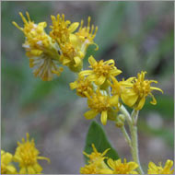
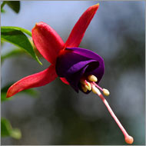
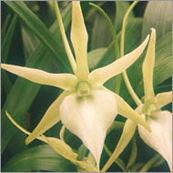

Sumatran corpse flower
Wild celery
Common blue violet
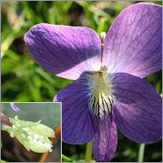
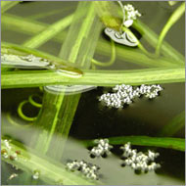
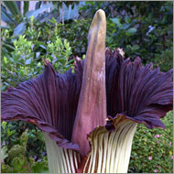

African baobab
