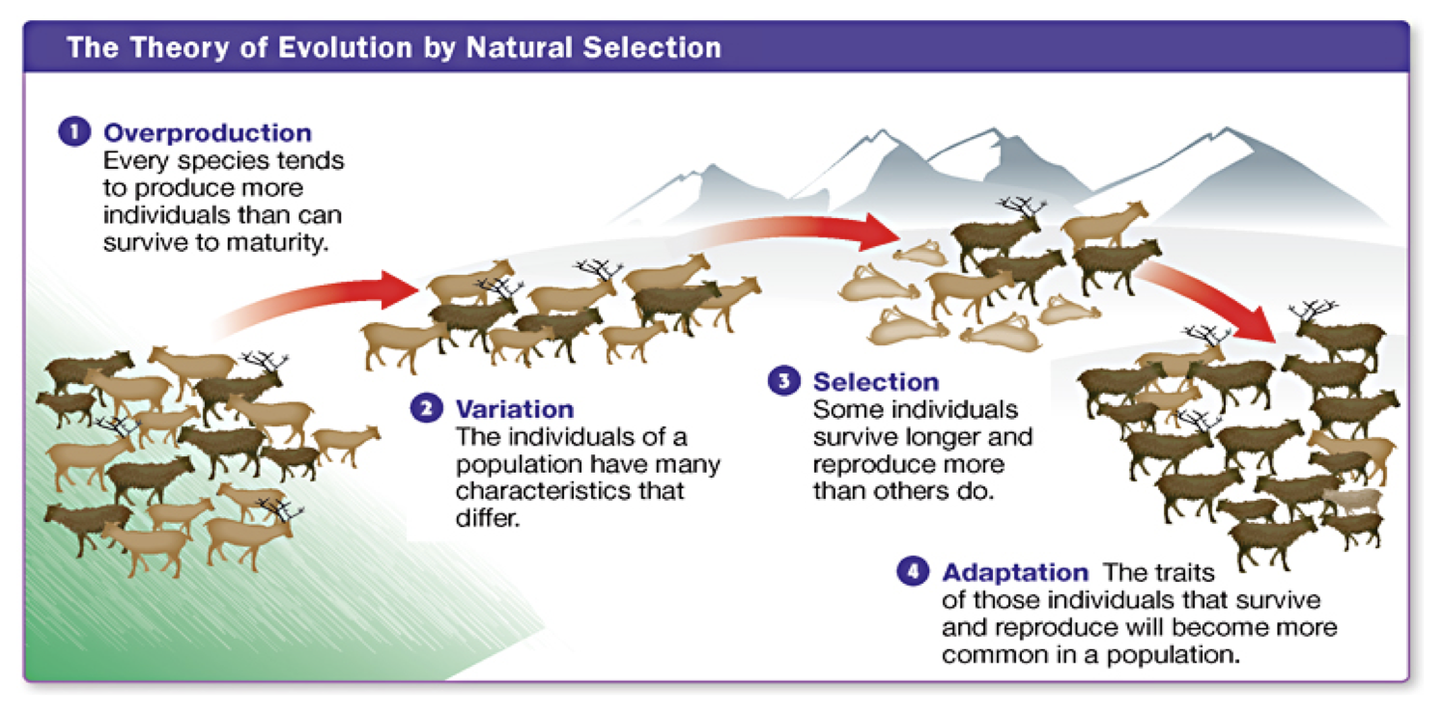

**Successful Reproduction**

The traits of those individuals that survive & reproduce will become more common in a population

**Struggle to** Survive

**Genetic Variation**

**Overproduction**