Name____________________________
I CAN explain photosynthesis and cellular respiration.

Period ___ Date ____________________
This will also be your STUDY GUIDE for Chapter 4 Section 2—Cell Energy
- complete this study guide,
- study—this study guide

If you do not receive a Proficient
grade on this test, in order to retake
you are required to:
have your parent sign this study guide.
My child had completed this study guide, studied, and is ready to retake this test.
_________________________________
parent signature

PHOTOSYNTHESIS
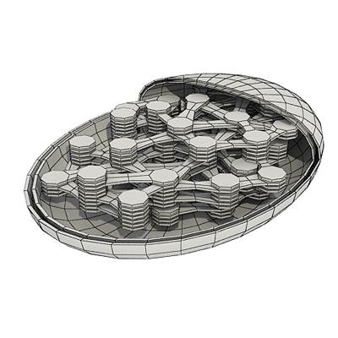
1. What kind of organisms have photosynthesis?

______________________

2. Where does the energy come from for photosynthesis?_____

3. What is the main product of photosynthesis? ____________

4. What useful gas is released to the air during photosynthesis? ___________________

GIVE A CHEMICAL DEFINITION OF PHOTOSYNTHESIS using these chemical element symbols C H O which stand for Carbon, Hydrogen, and Oxygen.

6.
9.
8.
5.
7.
9.
+ + +
RAW MATERIALS
PRODUCT
PRODUCT

10. In which plant part does photosynthesis take place? _________________
(The answer is NOT chloroplasts.)

11. What do chloroplasts do? _make __________________

12-16. Sketch a plant and place arrows in the sketch showing the photosynthesis cycle. Label arrows with the chemical symbols you used in 5-9 above.

Name____________________________
I CAN explain photosynthesis and cellular respiration.

Period ___ Date ____________________

CELL RESPIRATION
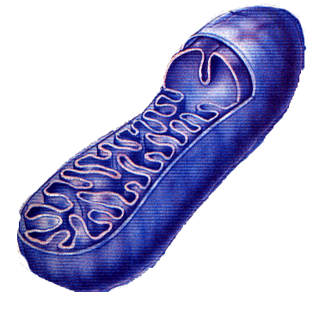
1. Cell respiration takes place in what organelle? _____________

2. Cell respiration requires what gas to be present? __________

3. 3. Cell respiration uses what food? ________________

4. Cell respiration produces what waste and side product? _________________

5. Cell respiration accomplishes what (main product)? ______________________

GIVE A CHEMICAL DEFINITION OF CELL RESPIRATION using these chemical element symbols C H O which stand for Carbon, Hydrogen, and Oxygen.
6.
5.
9.
8.
7.
+ + +

P R O D U C T S
RAW MATERIALS

10-14. Sketch a stick figure and place arrows in the sketch showing the cellular respiration cycle. Label the arrows with the chemical symbols you used in 5-9 above.

