

Name ____________________________Period___Date_______________________

**Photosynthesis**

**____ + ______ ____________ + _____**

____________ + _________ ­­­­­­­_______________ + ________

**Ca**

Light energy

**___________**

______________

________________

[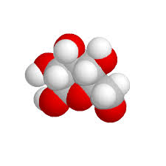](http://www.google.com/imgres?safe=active&sa=X&rls=com.microsoft:en-us:IE-Address&biw=1046&bih=692&tbm=isch&tbnid=C79_25SdTiWv3M:&imgrefurl=http://www.lionden.com/chemistry_models.htm&docid=NKQjPZ1DXHTXrM&imgurl=http://www.lionden.com/graphics/AP/glucose3.gif&w=460&h=460&ei=tvveUpWGLcegyAG4tIHwDg&zoom=1&ved=0CMoBEIQcMCM&iact=rc&dur=1328&page=3&start=33&ndsp=17)[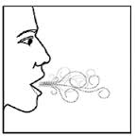](http://www.google.com/imgres?safe=active&sa=X&rls=com.microsoft:en-us:IE-Address&biw=1046&bih=685&tbm=isch&tbnid=lUd1Ltocy2nwHM:&imgrefurl=http://www.rxlist.com/aerospan-hfa-drug/medication-guide.htm&docid=SxS41zK5BKjE0M&imgurl=http://images.rxlist.com/images/rxlist/aerospan-hfa15.gif&w=179&h=181&ei=pMXeUquEBdLxoASA_oLwCw&zoom=1&ved=0CK8BEIQcMBo&iact=rc&dur=518&page=2&start=13&ndsp=17)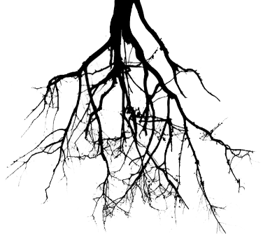[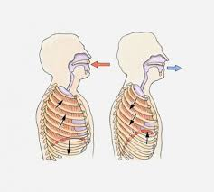](http://www.google.com/imgres?safe=active&sa=X&rls=com.microsoft:en-us:IE-Address&biw=1046&bih=685&tbm=isch&tbnid=IzgeB7O6EXOe9M:&imgrefurl=http://whartonmagazine.com/blogs/breathing-in-the-excitement/&docid=Z-_Jq7z7EzAAjM&imgurl=http://whartonmagazine.com/wp-content/uploads/2013/04/103311211-533x480.jpg&w=533&h=480&ei=CcbeUvHIFJC6oQSE0ILgAw&zoom=1&ved=0CPgCEIQcMF0&iact=rc&dur=1762&page=6&start=81&ndsp=19)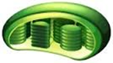[](http://www.google.com/imgres?safe=active&sa=X&rls=com.microsoft:en-us:IE-Address&biw=1046&bih=685&tbm=isch&tbnid=lUd1Ltocy2nwHM:&imgrefurl=http://www.rxlist.com/aerospan-hfa-drug/medication-guide.htm&docid=SxS41zK5BKjE0M&imgurl=http://images.rxlist.com/images/rxlist/aerospan-hfa15.gif&w=179&h=181&ei=pMXeUquEBdLxoASA_oLwCw&zoom=1&ved=0CK8BEIQcMBo&iact=rc&dur=518&page=2&start=13&ndsp=17)

**_____________________**

____________________________

___________________________________

Photosynthesis is important because __________________________

_________________________________________________________

___________________________________________________________

**______________**

___________________

___________________

**__________________**

___________________________

___________________________

**____________**

__________________

__________________

**___________ in the leaf:**

_______________________

________ ­­­­­­­­­­­­­­­­­

**Cellular Respiration**

**__________ + _____  _______ + _____+ _______**

____________ + _________  __________ + _________ + _________

[](http://www.google.com/imgres?safe=active&sa=X&rls=com.microsoft:en-us:IE-Address&biw=1046&bih=685&tbm=isch&tbnid=IzgeB7O6EXOe9M:&imgrefurl=http://whartonmagazine.com/blogs/breathing-in-the-excitement/&docid=Z-_Jq7z7EzAAjM&imgurl=http://whartonmagazine.com/wp-content/uploads/2013/04/103311211-533x480.jpg&w=533&h=480&ei=CcbeUvHIFJC6oQSE0ILgAw&zoom=1&ved=0CPgCEIQcMF0&iact=rc&dur=1762&page=6&start=81&ndsp=19)

**____________**

__________________

__________________

[](http://www.google.com/imgres?safe=active&sa=X&rls=com.microsoft:en-us:IE-Address&biw=1046&bih=692&tbm=isch&tbnid=C79_25SdTiWv3M:&imgrefurl=http://www.lionden.com/chemistry_models.htm&docid=NKQjPZ1DXHTXrM&imgurl=http://www.lionden.com/graphics/AP/glucose3.gif&w=460&h=460&ei=tvveUpWGLcegyAG4tIHwDg&zoom=1&ved=0CMoBEIQcMCM&iact=rc&dur=1328&page=3&start=33&ndsp=17)[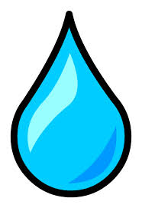](http://www.google.com/imgres?safe=active&sa=X&rls=com.microsoft:en-us:IE-Address&biw=1046&bih=692&tbm=isch&tbnid=bpkgdybWoGHJWM:&imgrefurl=http://clubpenguin.wikia.com/wiki/Water_Droplet_pin&docid=X5x396uQ3ulcEM&imgurl=http://static2.wikia.nocookie.net/__cb20130808183640/clubpenguin/images/a/a7/Water_Droplet_Pin.PNG&w=692&h=1009&ei=cuXeUqi6DMrwoATqp4GACA&zoom=1&ved=0CI4BEIQcMBI&iact=rc&dur=567&page=2&start=12&ndsp=18)[](http://www.google.com/imgres?safe=active&sa=X&rls=com.microsoft:en-us:IE-Address&biw=1046&bih=685&tbm=isch&tbnid=lUd1Ltocy2nwHM:&imgrefurl=http://www.rxlist.com/aerospan-hfa-drug/medication-guide.htm&docid=SxS41zK5BKjE0M&imgurl=http://images.rxlist.com/images/rxlist/aerospan-hfa15.gif&w=179&h=181&ei=pMXeUquEBdLxoASA_oLwCw&zoom=1&ved=0CK8BEIQcMBo&iact=rc&dur=518&page=2&start=13&ndsp=17)



**______________**

___________________

___________________

____________________________

**_____________________**

____________________________

_______________________________

**In the _________________:**

______________________ ____

___________________________­­­­­­­­­­­­­­­­­

**________________**

______________________

______________________

Cellular Respiration is important because _______________________

_________________________________________________________

___________________________________________________________

**__________________**

__________________________

___________________________

[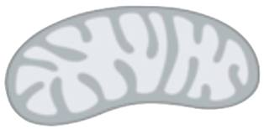](http://www.google.com/url?sa=i&rct=j&q=&esrc=s&frm=1&source=images&cd=&cad=rja&docid=YpQrKEOPdkx9fM&tbnid=tu3ruzFt7-GC2M:&ved=0CAUQjRw&url=http://www.clker.com/clipart-77218.html&ei=sMfeUqy4FInroASAtoCgBA&bvm=bv.59568121,d.cGU&psig=AFQjCNGsl5NBF2-H9XQ_1vdOcNVIpHVj4w&ust=1390418156735384)