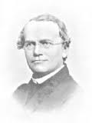Name:___________________________
I CAN explain how inherited traits are passed from generation to generation and how they are different than learned traits.

Period:_______ Date: ______________

Gregor Mendel’s Pea Lab

1. Make a Prediction: If a true-breeding a plant that has red flowers (R) is crossed with a true-breeding pea plant that has white flowers(r), what will the offspring look like? (Circle your prediction)
Materials:
paper sack,
post-it notes
red and white flower petals

a. All red flowers
b. All white flowers
c. Some red flowers and some white flowers
d. All pink flowers

2. Follow the directions below for the lab activity.
- WithOUT looking, draw from Experiment 1 bag a single pea plant petal and record in the data table by “Experiment 1” whether the petal is red or white. Put the pea petal back in the bag.

- Repeat step one ----- 12 times.

- Return this Experiment 1 bag and get Experiment 2 bag and two post-it-notes.

- Write “red Rr” on one post-it-note and “red Rr” on another post-it-note and stick them to the sack marked “experiment 2.”
These are the new parents—(which were the offspring from Experiment 1)

- Draw from bag 2 a single pea plant petal and record in the data table by “Experiment 2” whether the petal is red or white. Put the pea petal back in the bag.

- Repeat step five-----12 times.

- Calculate the ratios from experiment 1 and experiment 2.

- Talk to one another about the results that you have found. Record, in sentence form on the next page, about 3 observations, at least one of which should be unexpected.

Table
 | Red pea plants | White pea plants | *Ratio red: white
Experiment 1
RR x rr
Experiment 2

Rr x Rr
* ratios: red : white
examples 9 : 3 = 3 : 1
“ 8 : 4 = 2 : 1

3. Record Observations about your two experiments.

Observation 1:

Observation 2:

Observation 3:

4. Do your results agree with your original prediction? ________________

5. In each “bubble”, draw colored pictures of the petals and label with the genotype of the pea plants “parents” and pea plant “offspring” for both stages of Mendel’s experiment. In the text boxes, write red or white for the phenotypes. (#1 Parents have been done for you).
inside ovals are the genotypes
inside the rectangles are the phenotypes
(1) Parents…

r r
RR

red
(2) Offspring…
ALL
____________
ALL

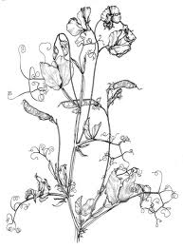
(3) Parents…

(4) Offspring…

