MARK YOUR CALENDARS!
FIRST TWO FIELD TRIPS OF THE YEAR-TEAM 7.3
$5.00 covers both field trips!
Field Trip 1-FORT VANNOY FARMS in Grants Pass
Thursday, October 6th
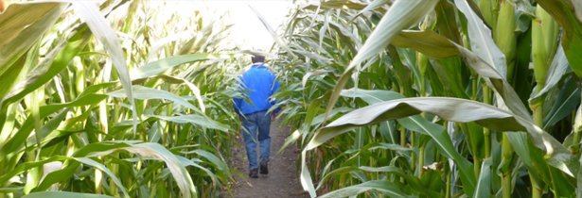
Students will learn:
- how plants are the most important storage of energy
- about daily life on a farm
Sponsored by the Agri-Business
Council of Oregon

- farming career opportunities
- and can you complete the Corn Maze challenge?

Wear appropriate walking shoes that can get dirty/muddy (depending on the weather) and wear layers for warmth. NO FLIP-FLOPS!

Who: ALLTeam 7.3 Hedrick Middle School students
Date/Time: October 6th 8:50 a.m. load buses and depart at 9:00 a.m. (Return by 3:00 p.m.)
Location: Fort Vannoy Farms, 5791 Lower River Road, Grants Pass
What to Bring: Sack Lunch and refillable water bottle
__________________________________________________________________________________________
SOU FALL IN THE FIELD
AT ASHLAND POND-Field Trip 2
the first week in November

The first half of the day students will learn:
Questions: Contact Mrs. Becky Plankenhorn at becky.plankenhorn@medford.k12.or.us
- about riparian ecology
- how to make bird and wildlife observations
- macroinvertebrate collection techniques
- how to test water quality
The second half of the day students will focus on a service learning experience of restoration activities such as: invasive plant species removal and native plant monitoring.

Who: ALL Team 7.3 Hedrick Middle School students
Date/Time: A different 1/3 of our team will attend one of these dates: * Nov. 1st, 2nd, OR 3rd 8:20 a.m. load buses and depart at 8:30 a.m. (Return by 3:00 p.m.)
*the other 2/3 of our team will attend a regular day of school
Location: Ashland Pond is located on the north side of Ashland on 11 acres that borders Ashland Creek and the Bear Creek Greenway.
What to Bring: Sack Lunch and a refillable water bottle in a daypack

Both field trips: Wear appropriate walking shoes that can get dirty/muddy (depending on the weather) and wear layers for warmth. NO FLIP-FLOPS!
Please complete and return this page and $5 with your child
ON OR BEFORE WEDNESDAY, SEPTEMBER 21, 2016

_______________________________has permission to attend the Fort Vannoy Farm field trip on October 6th AND the Fall in the Field SOU Ashland Pond field trip on one of these dates: November 1st, 2nd, OR 3rd.

Signed:_____________________________/_______Emergency contact number:_______________________

List any medical, dietary and other concerns that are important to share with us:

_______________________________________________________________________

_______________________________________________________________________

Payment/Scholarships
Every year we have many students that request field trip scholarships. If you are able to help another student, thank you for including additional funds.

I have included $5

I have included $5 and $_______for scholarship(s) for another student(s).

My child needs a scholarship. I have given a brief explanation why on the back of this slip.

CHAPERONES!
This is the first of several field trips we are planning this year. We will need several parent volunteers to accompany us on both trips. However, most importantly, we need one chaperone for every 5 students, (that’s 8 chaperones each of the 3 days), on the Ashland Pond experience. We invite you to join us, as you are what helps to assure that these trips are a success. We need chaperones!!!

If interested, please check below and return the bottom portion of this form
by Wednesday, September 21st.

I would like to chaperone the Fort Vannoy field trip on October 6th and will complete necessary VIMS forms available online ON or BEFORE Wednesday, September 21st.

I would like to chaperone the *Ashland Pond field trip and will complete necessary VIMS forms available online ON or BEFORE Wednesday, September 21st.
Please check which date you are available to chaperone: Nov. 1 Nov. 2 Nov. 3

Parent Chaperone Name _______________________________________________________

Student Name _______________________________________________________________

Phone Number _______________________________________

