Name ________________________________
Period_______Date_____________________

Pangaea

- About 300 million years ago, all seven of Earth’s continent made up one massive Supercontinent called Pangaea. The word Pangaea, when broken up into root words means: entire (Pan) and “Gaea” is the Greek word for Earth. It was surrounded by one ocean called Panthalassa.
- All 7 continents today are in their present positions on the Earth due to plate tectonics. All seven continents rest on plates, or large pieces of the Earth’s crust that float and move upon a hot, liquid mantle. These plates, as a result, fit together like a puzzle, into one land mass 300 million years ago. The land mass broke up into 7 smaller plates that drifted away from each other. When the plates are fit back together again, it is like stepping back in time.
- Index fossils such as Mesosaurus were widespread and found over several continents and land masses such as South America, Africa, Antarctica and India. Several of these continent and landmasses also hare the same types of rock layers and geological features.

- In this activity, you will cut out the land masses and fit them together into the Supercontinent of Pangaea.

- Instructions:

1. Cut out the puzzle pieces.
2. Fit the puzzle pieces into the supercontinent of Pangaea. Use the fossil distribution to help you place landmasses together in the correct positions.
3. Paste them on a separate sheet of paper. Color each of the fossil distribution areas a according to the colors indicated.
4. Analyze each fossil distribution area and record the landmasses where each
of the fossils were found.

ANALYSIS OF FOSSIL DISTRIBUTION

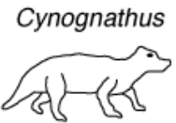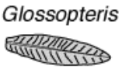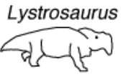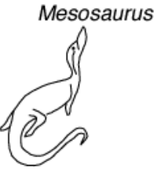
yellow
green
pink
blue

1. Record in which landmasses each of the fossil species were found:

a. Mesosaurus: _______________________________________
b. Cygnonathus: _______________________________________
c. Lystrosaurs:________________________________________
d. Glossopteris:________________________________________
_________________________________________
2. Which fossil species was found on the most landmasses? _______________________
3. Which fossil was found the least? _________________________________________
4. Which fossil was identified as a plant? ____________________

