Name ___________________________
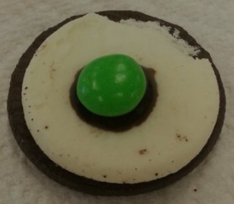
Period _____Date__________________

Layers of the Earth with OREOS!

Objective: Create a simple model to represent
the four layers of the Earth.

Materials:
- Oreo cookie with cream
- Chocolate syrup
- M & M
Procedure:
1. Carefully open Oreo cookie to keep cream on one side.
2. Eat the side of the Oreo without the cream.
3. Place a small amount of chocolate syrup in the middle of the cream part of the Oreo.
4. Place an M & M (with the ‘M’ face down) in the middle of the chocolate syrup.
5. Answer the following questions about what represents each layer of the Earth.
6. Follow along on the PPT for the fill-ins.

Questions:

1. The outside of the cookie represents what layer of the Earth? CRUST
The CRUST is hard and rigid. It is the Earth’s OUTERMOST and
THINNEST layer. The crust under the ocean is called the
OCEANIC CRUST. It is approximately 7 to 10 km thick.
The crust that forms the layers of rocks that forms the continents is called the CONTINENTAL CRUST. It is approximately 35 TO
40 km thick.
2. The cream part of the cookie represents what layer of the Earth? MANTLE
The MANTLE is subdivided into three regions, UPPER, MIDDLE and LOWER.
It is a dense layer made of HOT, SEMISOLID ROCK located below the
CRUST and is about 3000 km thick.

3. The chocolate syrup represents what layer of the Earth? OUTER CORE
The OUTER CORE is the only LIQUID layer of the Earth. It is made
of IRON and NICKEL It is about 2,260 km thick.

4. The M & M represents what layer of the Earth? INNER CORE
The INNER CORE is an extremely hot and SOLID sphere
made of IRON and NICKEL. It is located at the center
of the Earth. It is about 1220 km thick.

