Name ___________________________
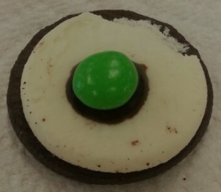
Period _____Date__________________

Layers of the Earth with OREOS!

Objective: Create a simple model to represent
the four layers of the Earth.
Materials:
- Oreo cookie with cream
- Chocolate syrup
- M & M

Procedure:
1. Carefully open Oreo cookie to keep cream on one side.
2. Eat the side of the Oreo without the cream.
3. Place a small amount of chocolate syrup in the middle of the cream part of the Oreo.
4. Place an M & M (with the ‘M’ face down) in the middle of the chocolate syrup.
5. Answer the following questions about what represents each layer of the Earth.
6. Follow along on the PPT for the fill-ins.

Questions:

1. The outside of the cookie represents what layer of the Earth?________________
The ______________is hard and rigid. It is the Earth’s __________________and ________________layer. The crust under the ocean is called the ________________________. It is approximately ______ to _______km thick. The crust that forms the layers of rocks that forms the continents is called the ___________________________. It is approximately _________to ________km thick.
2. The cream part of the cookie represents what layer of the Earth?______________
The _____________is subdivided into three regions, _________, ___________and _____________. It is a dense layer made of ________, _________________ located below the ___________and is about _____________km thick.

3. The chocolate syrup represents what layer of the Earth?______________________
The ___________________is the only _________layer of the Earth. It is made of _________and _________________. It is about ______________km thick.

4. The M & M represents what layer of the Earth?___________________
The ________________________is an extremely hot and _____________sphere made of _______________and _________________. It is located at the center of the Earth. It is about _________________km thick.
5. Draw a diagram of your Oreo and label the 4 layers of the earth.

6. EAT and enjoy your cookie
