ONION CELL AT 10x X 40x = 400x

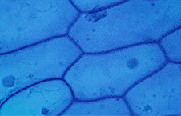

nucleus

cytoplasm

cell wall

cell membrane

ELODEA CELL 10x X 40x = 400x

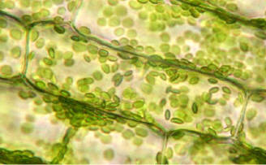

chloroplasts

cytoplasm

cell membrane

cell wall