Name_____________________
NEWLY DISCOVERED FISH SPECIES CREATION
Period____Date_____________

The following are a few scientific names of common fishes and their meanings.
Let’s review together to see how the scientific names relate to the fish they describe.
For example, in Latin melano means black and curvi means curved and taenia means banded. This might be describing a fish that has a black curved band on it.

Glowlight Tetra - Hemigrammus erythrozonus –
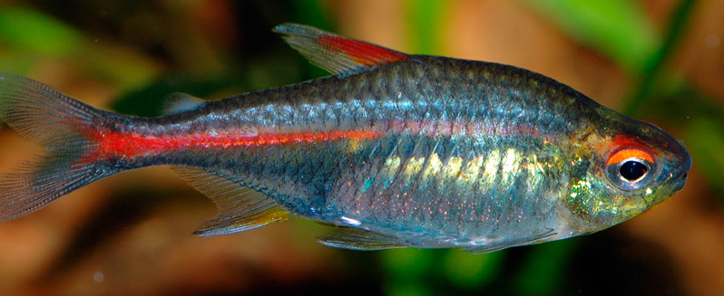
Hemi = half, grammus = mark, erythro = red, zonus = banded

Silver Shark - Balantiocheilus melanopterus
Balantio = bag, cheilus= lip,
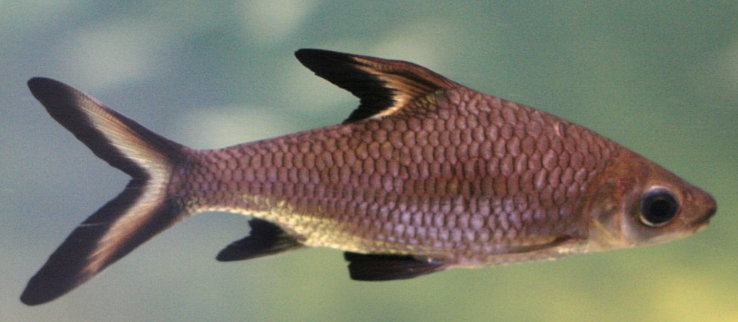
melano = black, pterus = fin)

Look at the table of Latin and Greek names to complete the Matching Exercise.
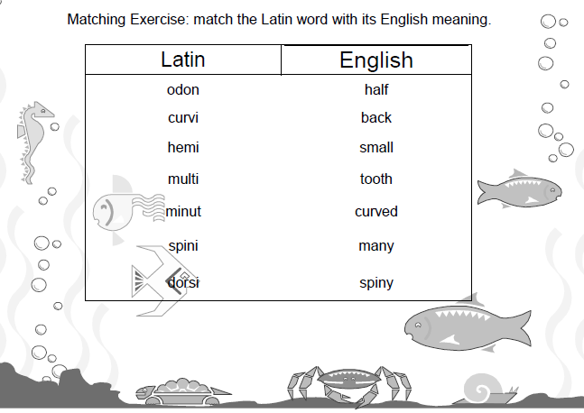

LATIN AND GREEK WORDS AND THEIR DEFINITIONS

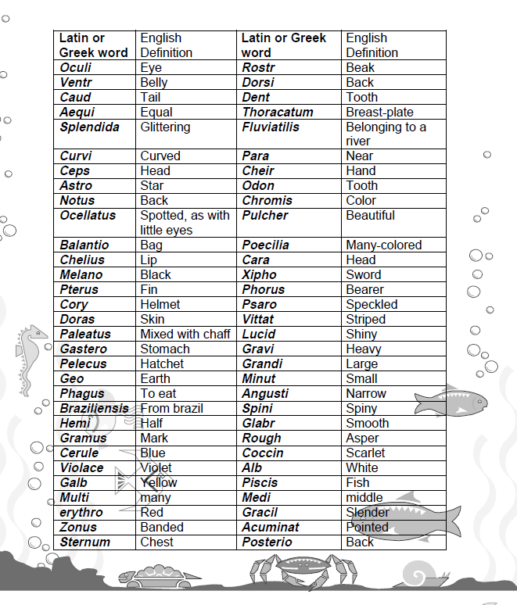

Name_____________________
Period____Date_____________

- You are an ichthyologist, a fish scientist. You are doing research deep in the Brazilian jungle in the Amazon River. You discover, what you think, is a new species of fish.
- Create a scientific name, Genus and species, for this newly discovered fish that matches the English definitions. (See table of Latin and Greek words.)
- Then illustrate (draw) the newly discovered species of fish below.

SCIENTIFIC NAME:

