Darwin’s Natural Selection Worksheet Name _____________________
I CAN explain how species change through the process of natural selection…
Period___Date_______________
Darwin’s Natural Selection in Four Steps:
1. Overproduction-more offspring are produced than can survive.
2. Genetic Variation-individuals in a population are varied (slightly different from each other).
3. Struggle to Survive-only some individuals in a population survive.
4. Successful Reproduction-individuals that are well adapted to their environment are more
likely to survive and reproduce.
Read the following situations below and identify the 4 steps of Darwin’s Natural Selection

1) There is one species of worms. Some of the worms eat at night (nocturnal) and some of the worms eat during the day (diurnal). The birds eat during the day and seem to be eating ONLY the diurnal worms. The nocturnal worms are in their burrows during this time. Each spring when the worms reproduce, they have about 500 babies but only 100 of these 500 ever become old enough to reproduce.
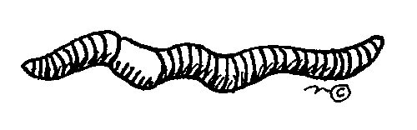

- What worm has natural selection selected AGAINST? _________________
- FOR? ________________

Darwin’s 4 steps: Identify the 4 steps in the scenario above.

--overproduction___________________________________________________________

--genetic variation__________________________________________________________

--struggle to survive_________________________________________________________

--successful reproduction_____________________________________________________

____________________________________________________

2) There are 3 types of one speices of polar bears: ones with thick coats, ones with thin
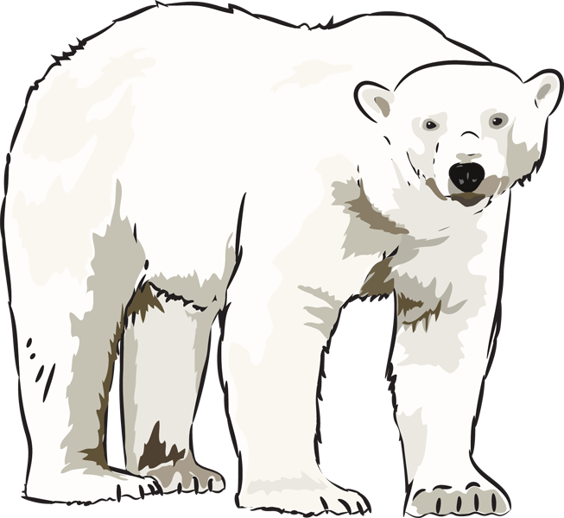
coats and ones with medium coats. It is fall, soon to be winter. The
temperatures are dropping rapidly and the bears must be kept warm,
or they will freeze to death. Many of the bears have had ~2 cubs each
but due to the extreme temperatures, many mothers only have one
cub left.

- What bear will natural selection select AGAINST? ___________________
- FOR? _________________

Darwin’s 4 steps. Identify the 4 steps in the scenario above.

1. overproduction ________________________________________________________

2. genetic variation _______________________________________________________

3. struggle to survive ______________________________________________________

4. successful reproducton __________________________________________________

____________________________________________________________________
3) In ostriches, there are 2 types of one species: ones that run fast and those that run slowly. The fast birds can reach up to 40 miles an hour. Jackals love to eat ostrich, and they can reach speeds of up to 35-40 miles per hour. A flock of ostrich will lay ~ 10 eggs (each mother only lays 1), but many rodents break into the eggs and eat the fetus before they hatch.
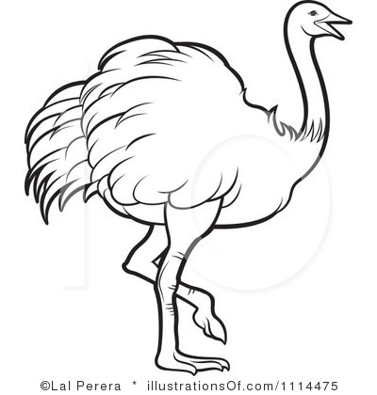

a. What ostrich will natural selection select AGAINST? __________________
b. FOR? ________________

Darwin’s 4 steps. Identify the 4 steps in the scenario above.

1. overproduction ________________________________________________________

2. genetic variation _______________________________________________________

3. struggle to survive ______________________________________________________

4. successful reproducton __________________________________________________

____________________________________________________________________

4) There are two types of one species of rabbits: those that strictly eat grass and those that strictly eat berries and flowers. A drought occurs one year, and the plants have difficulty producing any extras (flowers, berries, etc.). The plants can only try and keep themselves green (without producing flowers and berries.) The rabbits have had babies all year long but many are eaten by foxes or hawks.
Due to the drought, many have starved to death.

- What rabbit will natural selection select AGAINST? __________________
- FOR? _________________

Darwin’s 4 steps. Identify the 4 steps in the scenario above.

1. overproduction ________________________________________________________

2. genetic variation _______________________________________________________

3. struggle to survive ______________________________________________________

4. successful reproducton __________________________________________________

____________________________________________________________________

