MONSTER SCORING GUIDE
Name _________________________

P. ____Date____________________

_______“Your Monster” traits—23 traits—one point each
phenotype calculated correctly AND illustrated correctly

_______“Your Baby” traits—23 traits—one point each
phenotype calculated correctly AND illustrated correctly

_______ Strong Representation (Effort)—20 points possible
10 points for “Your Monster” and 10 points for “Your Baby”
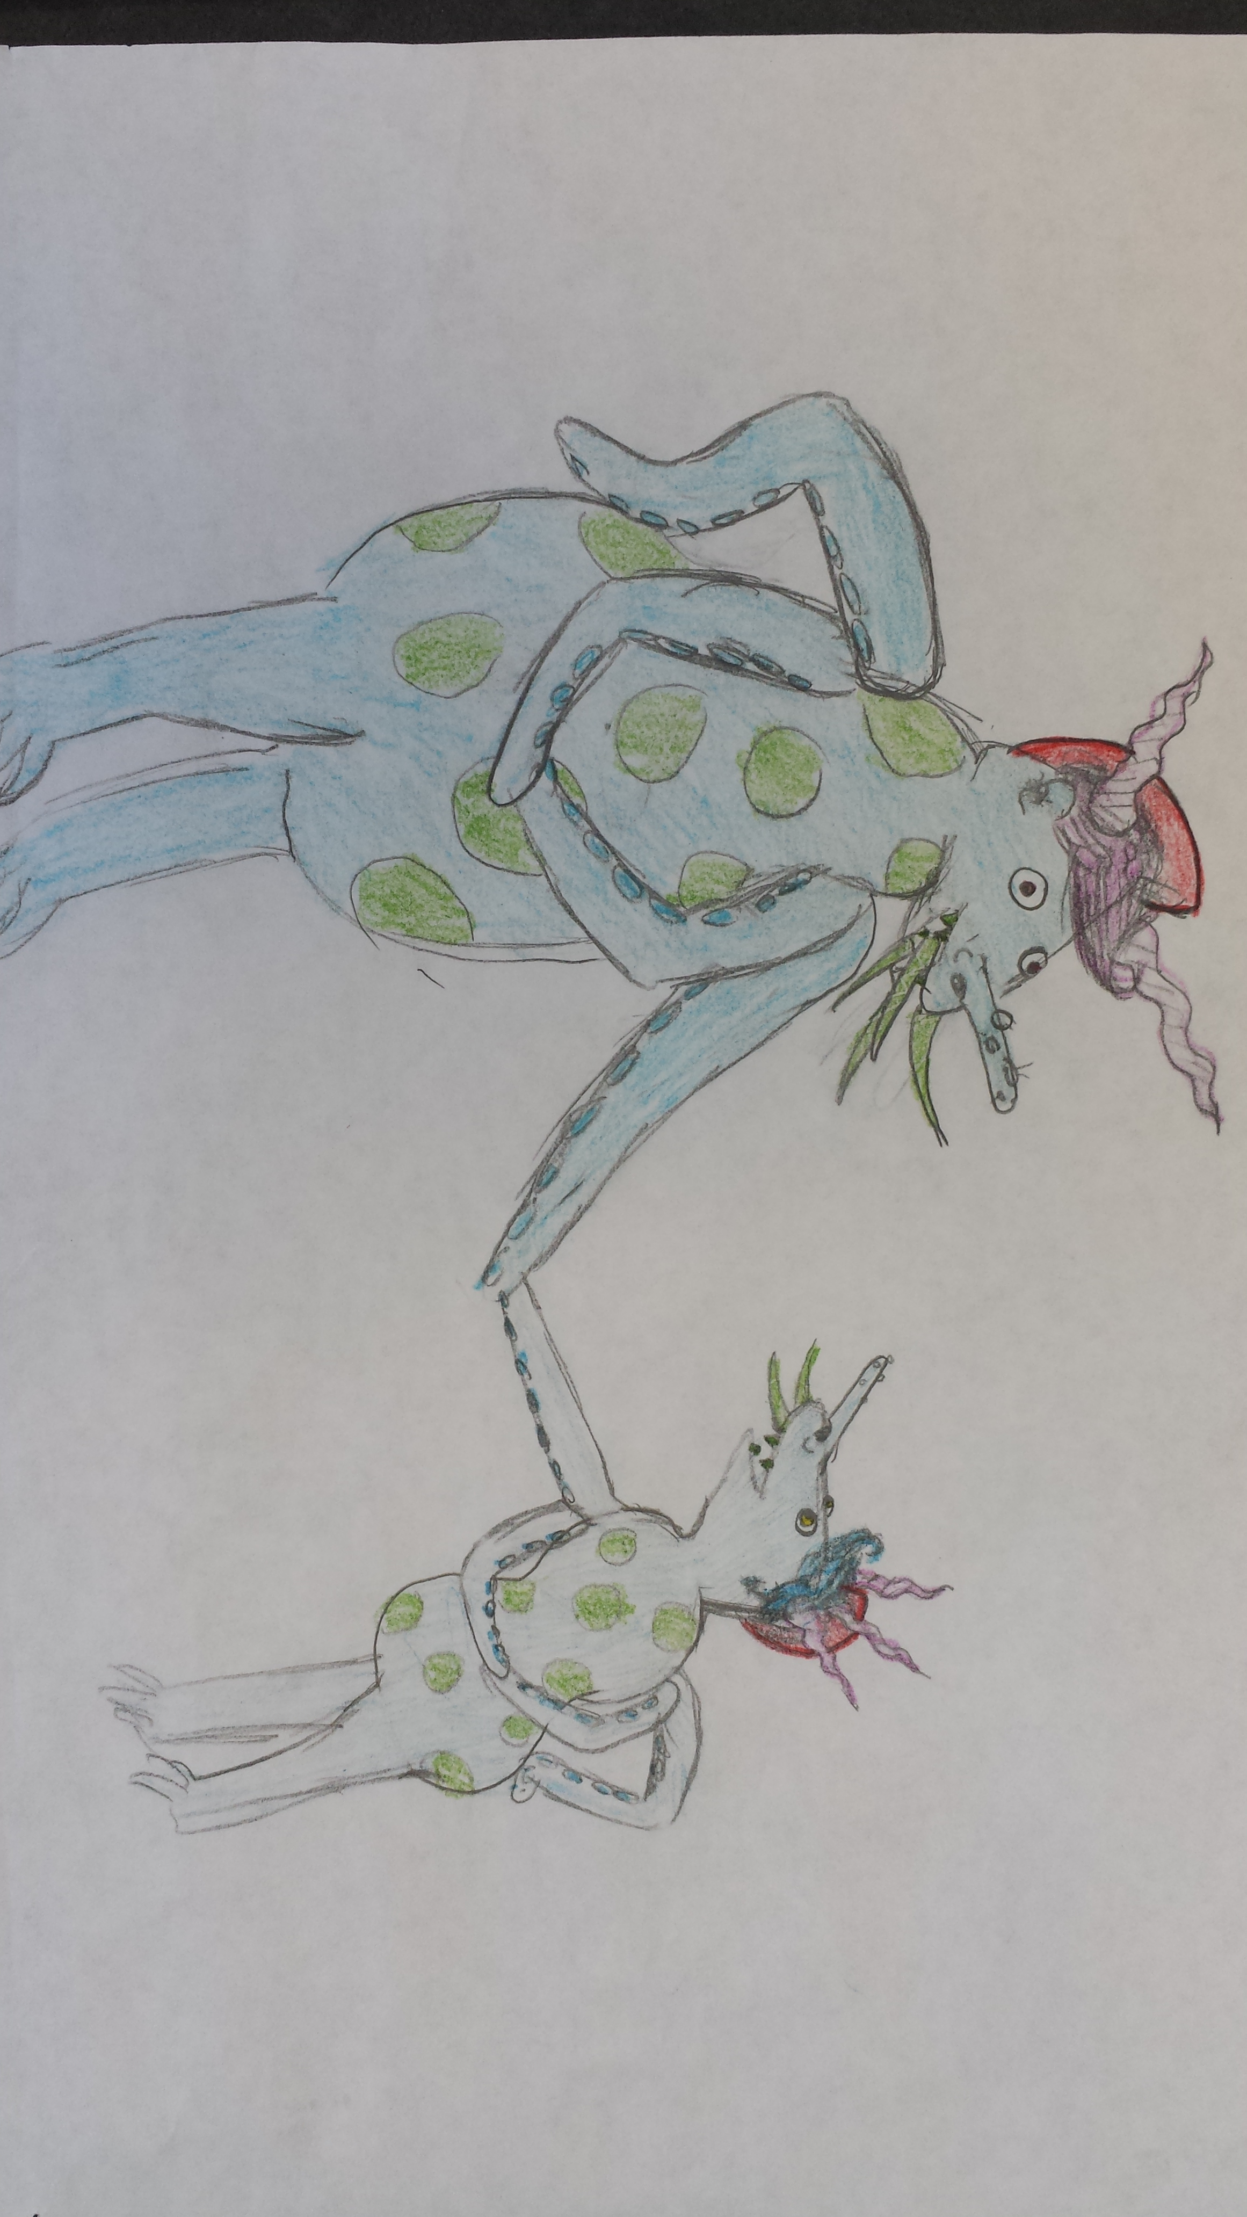
________ TOTAL points possible=66

TWO FORMATIVE GRADES
60 – 66 = Mastery
53 – 59 = Advanced
46 – 52 = Meets
39 – 44 = Approaching
38 or less= Beginning

MONSTER SCORING GUIDE
Name _________________________

P. ____Date____________________

_______“Your Monster” traits—23 traits—one point each
phenotype calculated correctly AND illustrated correctly

_______“Your Baby” traits—23 traits—one point each
phenotype calculated correctly AND illustrated correctly

_______ Strong Representation (Effort)—20 points possible
10 points for “Your Monster” and 10 points for “Your Baby”
________ TOTAL points possible=66

TWO FORMATIVE GRADES
60 – 66 = Mastery
53 – 59 = Advanced
46 – 52 = Meets
39 – 44 = Approaching
38 or less= Beginning

