Name _______________________________
-Males=brightly colored crests on head
AND hairy ears.
-Females=long eyelashes
AND pouch on both legs.
-ALL gene monsters have two legs, instead of arms they have tentacles like an octopus.

Period ____Date ______________________
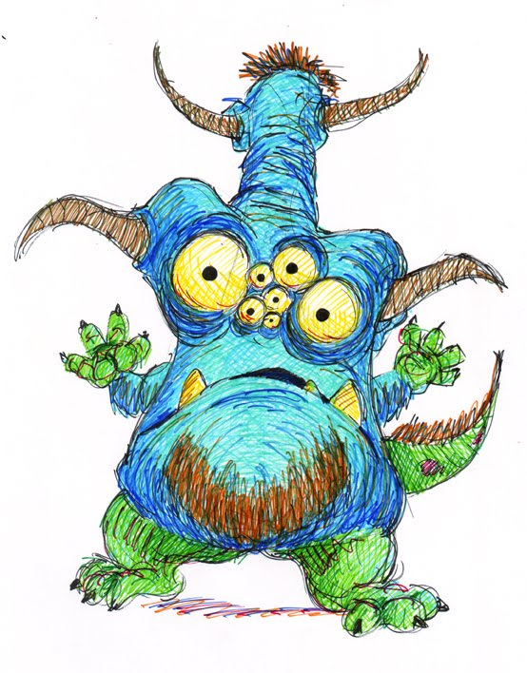
YOUR MONSTER

I CAN explain how inherited traits are passed from generation to generation ..

Papa Mama Your Your
Monster’s Monster’s Monster’s Monster’s
genotype genotype genotype phenotype

1. P p P p ____ ____ _____________________________________
2. T t T t ____ ____ _____________________________________
3. F f F f ____ ____ _____________________________________
4. L l L l ____ ____ _____________________________________
5. B b B b ____ ____ _____________________________________
6. S s S s ____ ____ _____________________________________
7. G g G g ____ ____ _____________________________________
8. L l L l ____ ____ _____________________________________
9. T t T t ____ ____ _____________________________________
10. B b B b ____ ____ _____________________________________
11. H h H h ____ ____ _____________________________________
12. C c C c ____ ____ _____________________________________
13. S^{G} S^{O} S^{Y} S^{O} ____ ____ _____________________________________
14. T^{L} T^{O} T^{U} T^{O} ____ ____ _____________________________________
15. O o O o ____ ____ _____________________________________
16. X Y X X ____ ____ _____________________________________
17. X Y Xa X ____ ____ _____________________________________
18. Xw Y Xw X ____ ____ _____________________________________
19. H h H h ____ ____
20. H h H h ____ ____
21 P p P p ____ ____
22. P p P p ____ ____
23. R r R r ____ ____
24. Y y Y y ____ ____

