Name _______________________________
-Males=brightly colored crests on head
AND hairy ears.
-Females=long eyelashes
AND pouch on both legs.
-ALL gene monsters have two legs, but no arms, instead having tentacles like an octopus

Period ____Date ______________________

BABY MONSTER
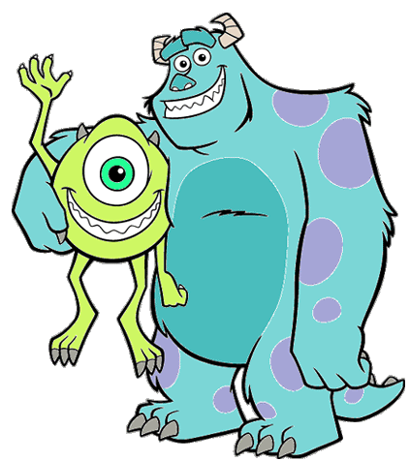

I CAN explain how inherited traits are passed from generation to generation and how they are different than learned traits.

YOUR ITS BABY BABY
Monster’s Mate’s Monster’s Monster’s
genotype genotype genotype phenotype

1. ___ ___ ___ ___ ____ ____ _____________________________________
2. ___ ___ ___ ___ ____ ____ _____________________________________
3. ___ ___ ___ ___ ____ ____ _____________________________________
4. ___ ___ ___ ___ ____ ____ _____________________________________
5. ___ ___ ___ ___ ____ ____ _____________________________________
6. ___ ___ ___ ___ ____ ____ _____________________________________
7. ___ ___ ___ ___ ____ ____ _____________________________________
8. ___ ___ ___ ___ ____ ____ _____________________________________
9. ___ ___ ___ ___ ____ ____ _____________________________________
10. ___ ___ ___ ___ ____ ____ _____________________________________
11. ___ ___ ___ ___ ____ ____ _____________________________________
12. ___ ___ ___ ___ ____ ____ _____________________________________
13. ___ ___ ___ ___ ____ ____ _____________________________________
14. ___ ___ ___ ___ ____ ____ _____________________________________
15. ___ ___ ___ ___ ____ ____ _____________________________________
16. ___ ___ ___ ___ ____ ____ _____________________________________
17. ___ ___ ___ ___ ____ ____ _____________________________________
18. ___ ___ ___ ___ ____ ____ _____________________________________
19. ___ ___ ___ ___ ____ ____
20. ___ ___ ___ ___ ____ ____
21 ___ ___ ___ ___ ____ ____
22. ___ ___ ___ ___ ____ ____
23. ___ ___ ___ ___ ____ ____
24. ___ ___ ___ ___ ____ ____

