Name________________________
Period____Date________________
MOLECULES IN MOTION
Objective: Describe how heating and cooling affects the motion and spacing of atoms in solids and liquids.

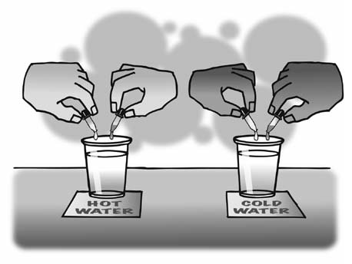
- Describe what the colors looked like and how they moved and mixed in the two different temperatures of water.
HOT:

COLD:
- Based on your observations and the animations, fill in the blanks with the words increases or decreases.

Heating a substance molecular motion.
Cooling a substance molecular motion.
As molecular motion increases, the space between molecules_____________. As molecular motion decreases, the space between molecules_____________.

- How is the motion of the atoms in solid metal different from the motion of the molecules in liquid water?
SOLID:

LIQUID:

- What is it about atoms and molecules in liquids and solids that keep them close to one another even though they are moving?
____________________________________________________________________________________________________________________________
- What happened when Mrs. Plankenhorn’s brave volunteer tried to push the heated ball through the ring?
____________________________________________________________________________________________________________________________
- What happened to the atoms in the heated metal ball?
____________________________________________________________________________________________________________________________
- After the ball was cooled by putting it in the water, why do you think it fit through the ring again?
____________________________________________________________________________________________________________________________
- Draw a model of the atoms in the metal ball at room-temperature and after it has been heated. Use circles/motion lines to show the speed/spacing of the atoms.
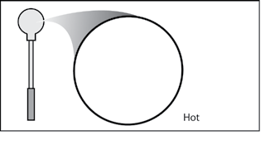
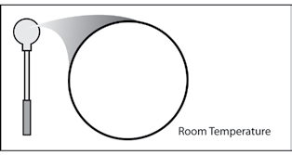

Let’s say that you measure exactly 100 mL of water in a graduated cylinder. You heat the water to 100 °C and notice that the volume increases to 104 mL.

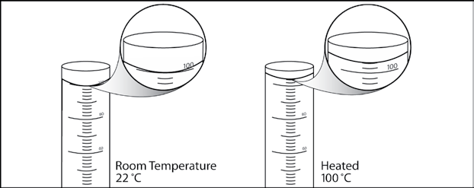
- Using what you know about the attractions between water molecules and the way heat affects molecular motion, explain why the volume of water in the cylinder increases when it is heated.
__________________________________________________________________________________________________________________________________________________________________________________________
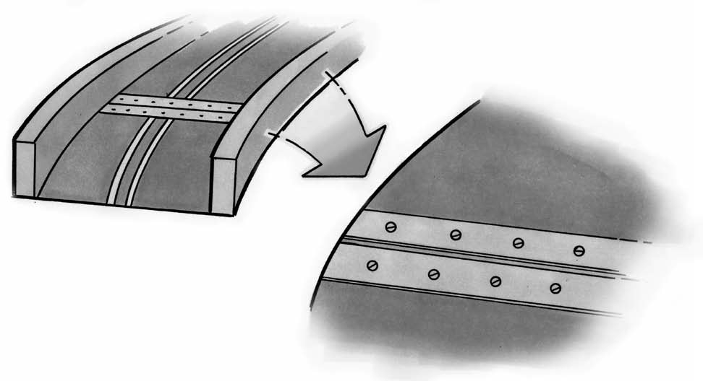
Look at the picture of the road of a bridge. The road on a bridge gets colder in the winter and hotter in the summer than the road leading to it and away from it. Many bridges have a flexible connection like the one shown in the picture.

- Knowing what you do about how solids act when they are heated and cooled, why do you think they put flexible connections in the road on a bridge?
__________________________________________________________________________________________________________________________________________________________________________________________

