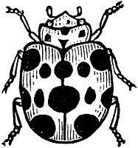
Name ____________________ Period ______

WHAT DO YOU NOTICE?
“MICROCOSMOS” VIDEO

1. Name an arthropod that you saw. ______________________________________________

2. Name an insect that you saw. _________________________________________________

3. Name an arachnid that you saw. _______________________________________________

4. The moth has pink on its wings. Why? Wouldn’t it be better if it was all camouflaged?
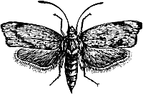

_________________________________________________________________

5. When the bee pushes on the flower its pollen maker comes down and gets pollen on the bee.

6. Have you ever seen a ladybug’s wings? __________________
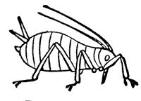
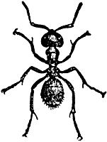
7. What do ladybugs eat? ________________________

8. Do ants like ladybugs______________________

9. Are ladybugs bugs? _______________

10. What do ants sometimes eat? ______________

11. How many spots do Seven Spotted Ladybugs have? _____

12. Draw the mouth part of the butterfly.
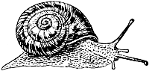
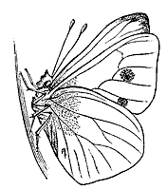

13. Describe a scene that shows a mollusk. Keep it PG.
__________________________________________________________________________

14. How do you tell worker ants from soldiers? _______________________________________

__________________________________________________________________________
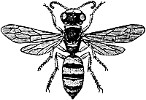
15. Do baby yellow jackets look like yellow jackets? _____________
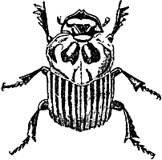
16. Dung beetles work hard!

17. Look at the mouth part of the water skimmer. What weapon does it look like? _____________

How Do Ants and Aphids Help Each Other?
Ants and aphids share a well-documented relationship of mutualism. Ants feed on the sugary honeydew left behind by aphids. In exchange, the ants protect the aphids from predators and parasites. In fact, honey ants will go to unusual lengths to ensure the health of the aphids in their care.
Answer:
Aphids suck the sugar-rich fluids from their host plants. Because these liquids are low in nitrogen, the aphids must consume large quantities of them to gain adequate nutrition. The aphids then excrete equally large quantities of waste, called honeydew, which is high in sugar content.
Where there's sugar, there's bound to be ants. Some ants are so hungry for the honeydew, they'll actually "milk" the aphids to make them excrete it. The ants use their antennae to stroke the aphids, stimulating them to release the honeydew. Some aphid species have lost the ability to poop on their own, and now depend on their caretaker ants to milk them.

What does the Sacred beetle, type of dung beetle, do with its pill of sheep droppings?
The sacred scarab beetle in this picture doesn't look to me like a bug anybody would want to worship but I'd be wrong. This is Scarabaeus sacer, one of the varieties of dung beetle and its image is found in ancient Egyptian temples, the Pyramids and other Egyptian archaeological sites.
It looks quite threatening with those large pincer like legs at the front but this is one of the beetles that does a very useful job in clearing rotting material and helping to fertilise the soil.

Why does the rare-Argyronet spider need a ‘diving bell’?
The only species in this genus, Argyroneta aquatica, is also known as the water spider. It is a special spider because it lives in water. The scientific name of the spider, Argyroneta, means 'with a silvery net'. The silvery net is the air bubble that surrounds the spider, which it needs to breathe. Special hairs on the skin of the spider give it the ability to keep the air attached to its body. The spider has to go to the surface regularly to refresh the air.
Argyroneta aquatica constructs a web under water and fills it with air. She catches air from the surface and releases the air bubble from her body with her legs. This is repeated until there is enough air in her 'diving bell'. Diffusion and oxygen bubbles released by the water plants also add air in the bubble. Prey is caught under water, killed by a poisonous bite and consumed in the air bubble in her web. The spider is a good hunter under water and swims quickly between the water plants. Change of skin is done outside the water or in a separate diving bell.

Why do you think the Processionary caterpillars have this name?
Case in point: the processionary caterpillar. The noted French naturalist, Jean Henri Fabre`, studied this unique little furry insect in great detail. What makes this caterpillar special is its instinct to follow in lock step the caterpillar in front of it. This behavior, not only gives the caterpillar its name, but a deadly characteristic also.
Fabre` demonstrated this unusual behavior with a simple experiment. He took a flowerpot and placed a number of caterpillars in single-file around the circumference of the pot’s rim. Each caterpillar's head touched the caterpillar in front of it. Fabre` then placed the caterpillars' favorite food in the middle of the circle created by the caterpillars’ procession around the rim of the flowerpot. Each caterpillar followed the one ahead thinking that it was heading for the food. Round and round went those silly insects--for seven days! After a week of this mindless activity, the caterpillars started to drop dead because of exhaustion and starvation. All that they had to do to avoid death was to stop the senseless circling of the flower pot and head directly toward the food—less than six inches away from those ever-circling crawlers. However, the processionary caterpillars were locked into this lifestyle and couldn’t extricate themselves from this mindless behavior.

Which horned beetle looks remarkably like a large animal?
It’s the Rhino Beetle—strongest animal in the world—lifting 850 times its weight.

Other possible questions to ask:
What living things made a tasty feast for the pheasant?
How does the thunderstorm affect some of the living things?
Which living thing in the film has the most legs?

other species in video
swallow-tail butterfly
great peacock moth—largest European moth -6 in wingspan (1 ft Atlas in Asia)
wriggler changes into a mosquito

