Name _____________________________________
Standard 73.1
I CAN design a good controlled scientific investigation.
Period ___ Date_____________________________

MEASURING LEAVES IN CM AND MM
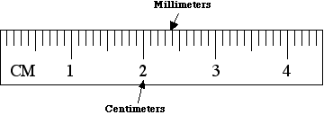
This is the metric side of the ruler.
This is 1 cm which = 10 mm

Measure 10 leaves in cm. THEN convert cm to mm.
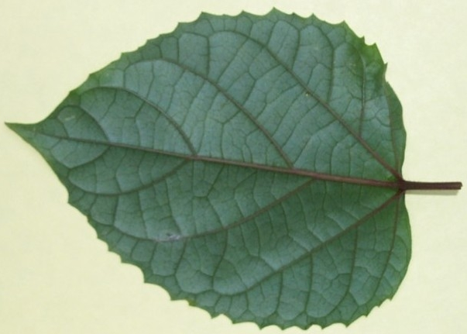
Measure the leaf from the tip to the base of the leaf (NOT the end of the stem).
This leaf measures:
3.4 cm
34 mm

cm mm

1. _____ _____
The range is __________ mm
___________minus ____________ mm = range.
longest - shortest = range
(Subtract the shortest leaf mm from the longest leaf mm.)

The Mean (average) leaf length is ____________mm.
(Take the total length of leaves mm and divide
by the number of leaves.)
2. _____ _____

3. _____ _____

4. _____ _____

5. _____ _____

6. _____ _____

7. _____ _____

8. _____ _____

9. _____ _____

10. _____ _____

_____ TOTAL

