CLASS COPY DO NOT WRITE ON THIS
OR TAKE THIS COPY!

Endothermic vs. exothermic reactions
Let's see what Sam and Julie are up to in the chemistry lab.
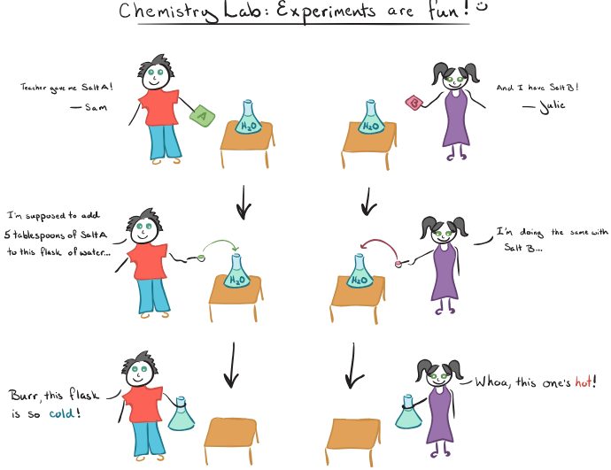Excited but a bit confused, Sam and Julie run to their chemistry teacher. Sam asks, “Teacher, why did my flask turn cold after adding the salt to water, while Julie’s flask turned hot?”
The teacher replies: “That’s because you were given two different salts. One of your salts generated an endothermic reaction with water, while the other salt generated an exothermic reaction with water. Let me first reveal the identity of your salts: Salt A is ammonium nitrate (NH₄NO₃) and Salt B is calcium chloride (CaC1₂)
Now, Sam and Julie are curious about the difference between an endothermic and an exothermic reaction.
Consider the reaction mixture—salt plus water—as the system and the flask as the surrounding.
In Sam’s case, when ammonium nitrate was dissolved in water, the system absorbed heat from the surrounding, the flask, and thus the flask felt cold. This is an example of an endothermic reaction. In Julie’s case, when calcium chloride was dissolved in water, the system released heat into the surroundings, the flask, and thus the flask felt hot. This is an example of an exothermic reaction.
The reaction going on in Sam’s flask can be represented as:
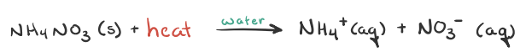
You can see, heat is absorbed during the above reaction, lowering the temperature of the reaction mixture, and thus the reaction flask feels cold.
The reaction going on in Julie’s flask can be represented as:
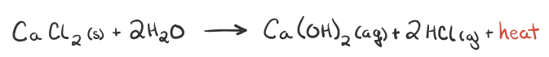
In this case, heat is released during the reaction, elevating the temperature of the reaction mixture, and thus Julie’s reaction flask feels hot.
The teacher’s final comment to Sam and Julie about this experiment is, “When trying to classify a reaction as exothermic or endothermic, watch how the temperature of the surrounding—in this case, the flask—changes. An exothermic process releases heat, causing the temperature of the immediate surroundings to rise. An endothermic process absorbs heat and cools the surroundings.”
Based on the above definition, let's pick a few examples from our daily lives and categorize them as endothermic or exothermic.

Endothermic reactions: Heat is absorbed.
1) Photosynthesis: Plants absorb heat energy from sunlight to convert carbon dioxide and water into glucose and oxygen.

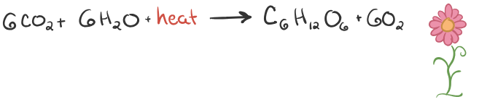
2) Cooking an egg: Heat energy is absorbed from the pan to cook the egg.
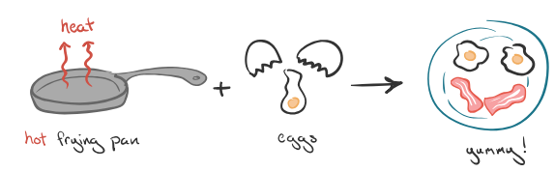

Exothermic reactions: Heat is released.
1) Combustion: The burning of carbon-containing compounds uses oxygen, from air, and produces carbon dioxide, water, and lots of heat. For example, combustion of methane (\text{CH}_4CH4​C, H, start subscript, 4, end subscript) can be represented as follows:
2) Rain: Condensation of water vapor into rain releasing energy in the form of heat is an example of an exothermic process.

Why is heat released or absorbed in a chemical reaction?
In any chemical reaction, chemical bonds are either broken or formed. And the rule of thumb is "When chemical bonds are formed, heat is released, and when chemical bonds are broken, heat is absorbed." Molecules inherently want to stay together, so formation of chemical bonds between molecules requires less energy as compared to breaking bonds between molecules, which requires more energy and results in heat being absorbed from the surroundings.

