Name_______________________________
P. ______Date________________________
Kingdom Mystery Organisms

First, read the “Description” of the organism. Next, figure out what the organism is called and write the Organisms’ Name and the Kingdom the organism belongs to in the blank provided.
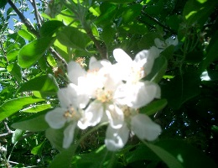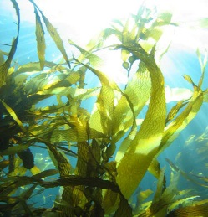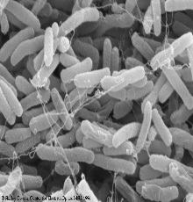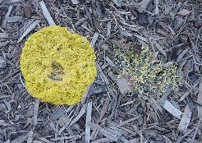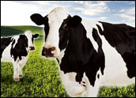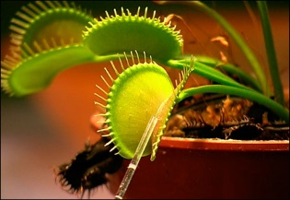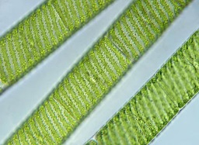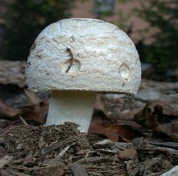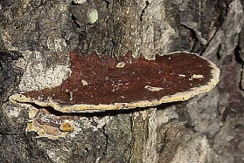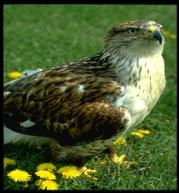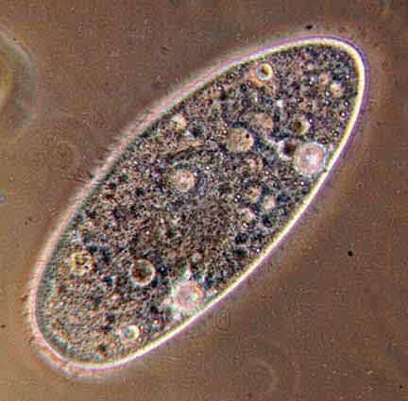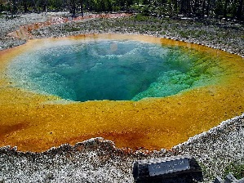

Organism Names: shelf fungus, paramecium, apple tree, kelp, mushroom, E. coli, slime mold,
Venus flytrap, thermophilic microbes, cow, algae, hawk
Kingdom Names: Eubacteria, Archaebacteria, Plantae, Protista, Animalia, Fungi

 | Description | Organism Name | Kingdom
1 | I am a multicellular, photosynthetic, marine, organism with motile sperm cells. I grow very fast and live my adult life attached to rocks being pounded by waves. I am plant like, but I have a simple body without complex specialized cells such as roots.
2 | I am a single-celled, prokaryotic organism that lives in the large intestines of mammals like humans. I reproduce asexually by binary fission (splitting in half) and can reproduce this way very fast.
3 | I am a multicellular producer that lives on land. I grow flowers with eggs and pollen inside them, and produce seeds inside of fruits. I;m a producer.
4 | I am a single celled organism that lives in pondwater. My body is covered with cilia (little hairs that I use to move me around), and I can swim very fast. I eat bacteria. I’m animal like.
5 | I am both unicellular and multicellular depending on how old I am. When I am getting ready to reproduce, my cells join together to make a slippery, slithering mass that is bright orange. When mature, I dry out and release millions of spores. I eat by digesting dead leaves and absorbing the nutrients. My name is tricky—I’m not truly a mold.
6 | I am multicellular, and my body is shaped like a thread. I live in water and turn it bright green when my population explodes. I reproduce sexually. I’m plant like but do not have roots, stems, or leaves.
7 | I am a multicellular consumer that eats by ingesting grass. My species have males and females, and we cannot reproduce asexually.
8 | I am enormous but mostly invisible because my body is hidden under soil. When sexually mature I make spores in fruiting bodies that rise above the soil and release millions of spores. I eat by digesting dead plant material in the soil as I grow through it.
9 | I grow inside living trees and slowly decompose their wood, making it rot. I got inside the tree back when I was a spore that landed on a wound made by a weed-eater. My body is a whitish, thready mass called a mycelium. I eventually kill my host tree. I am a eukaryote.
10 | I am a fast-moving multicellular predator. My body has organs and tissues. I have excellent eyesight and my favorite food is ducks. I can fly
11 | I am photosynthetic and multicellular. I make my own glucose food from sunlight, but get my fertilizer from insects I can catch in my folding leaves.
12. | I am a single celled prokaryotic organism. I live in hot springs where you would think that nothing could survive.

