**Name ___________________________**

**P. ___Date_______________________**

***Daphnia* Lab PreLab**

**Background on *Daphnia***

*Daphnia* are tiny **crustaceans**, never growing larger than a couple of millimeters no matter how well they eat. They are sometimes called water fleas because they are about that size and superficially look like fleas. But unlike fleas they are nearly transparent, **live in water**, have a shell, and are graced with an interesting array of modified appendages for sensing, feeding, and swimming. *Daphnia* are free swimmers, propelling themselves with surprising speed, considering they use a pair of modified antennae to swim. As they travel they filter even tinier organisms from the water. They **feed on single-celled algae, yeast, and bacteria.** *Daphnia* in turn are eaten by fish and aquatic insects. It seems that their role in life is to provide a snack for a larger organism.

**Reproduction**. Reproduction is an interesting business with *Daphnia*. Under optimum conditions of ample food and moderate temperatures, most of the *Daphnia* in a colony are female. They produce eggs without mating (asexual reproduction) by a process called parthenogenesis. The 50 or so eggs are held in the brood chamber for a few days until hatching, and then out comes the new generation of *Daphnia*. This will continue indefinitely as long as conditions are favorable. When *Daphnia* are stressed, however, they produce about equal numbers of males and females, and the offspring mate. After mating, (sexual reproduction) the female *Daphnia* produce hard-shelled eggs (cysts) that can withstand harsh conditions for a long time, even complete drying out. When conditions are once again favorable, the cysts hatch and the process repeats.

***Fill in the missing words from the box below to complete the paragraph about human reproduction.***

**uterus, human, one egg, nucleus, reproductive, DNA, 9 months**

The **organism** that produced you was a ______________. This was possible because of an **organ system** they possess called the ________________ system. The **organ** in the system that is most directly involved in incubating the offspring is the _______________. Females normally produce _____ _______ per month.

___ __________ is the approximate length for a human baby to develop before birth.

***The following paragraph lists some characteristics of the Animalia Kingdom that humans are a part of.***

***Fill in the missing words from the box below to complete the paragraph.***

**terrestrial (land) and aquatic, consumers, multicellular, mammals, sexually, cell walls, Eukaryotes**

All organisms in this kingdom have many cells called ________________. **Most** reproduce ___________________. They obtain their food from eating plants or other organisms and are known as __________________. All members of this kingdom contain a nucleus and are called ________________. They do NOT contain any _________ ____________. Organisms in this kingdom live in both ___________________and __________________ habitats. Examples of organisms in this kingdom include insects, birds, reptiles, fish, amphibians, arthropods such as crustaceans, and ______________which humans are a part of.

**Purpose**

In this lab, you will look at an example of a crustacean called *Daphnia* (water flea). You will compare some similarities of the *Daphnia* to a human to decide if Daphnia are in the Animalia Kingdom. (You will also compare differences of the Daphnia and human reproduction and growth and development.)

**Question**: Does *Daphnia* belong in the Kingdom Animalia, Protista, or Eubacteria?

**Materials:**

***Daphnia* Lab**

* microscope
* depression slide
* cover slip
* eye dropper
* beaker with water
* *daphnia*

**Procedure**

1. Carefully suck up ONE daphnia with an eyedropper.
2. Carefully squeeze the eyedropper until a daphnia lands in the depressed part of the slide.
3. Gently place a cover slip on the slide.
4. Look at the daphnia under the microscope on the lowest power.
5. Look at the diagram of the daphnia and find your daphnia’s brood chamber. Start on low power and go up to higher powers if you like. Determine if the daphnia is pregnant and record your findings on the table below. If it is pregnant there will be eggs in the brood chamber. Don’t confuse the legs with the brood chamber! The legs are on the same side as the eye and mouth, the brood chamber is toward the ‘back’. You can usually see a single black spot on each baby in the brood chamber. The black spot is the baby’s eye.
6. You may return your daphnia and obtain another two or three times.
7. Most daphnia will **NOT** be pregnant. If you are lucky and find a pregnant one, share it with others. Put all materials away before moving on to the analysis questions.

**Data**

|  |  |  |
| --- | --- | --- |
| **Daphnia name**  **(make it up)** | **Pregnant? (Yes/No)** | **If pregnant, how many offspring?** |
|  |  |  |
|  |  |  |

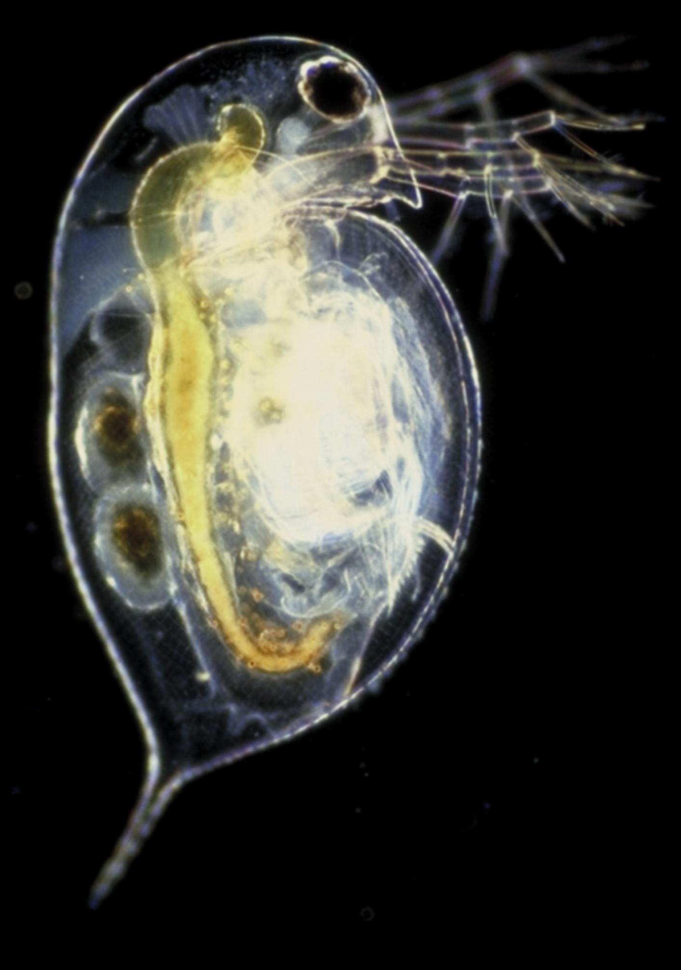

***Daphnia* Post Lab**

**Analysis—Kingdom and Reproduction**

1. What was the name of the organism you were looking at under the microscope? _______________

2. Do you think Daphnia is multi cellular?_____________________Why?_______________________

________________________________________________________________________________

3. Write down the sentence that proves that Daphnia are consumers from the first paragraph on page 1.

________________________________________________________________________________

________________________________________________________________________________

3. Does Daphnia live in aquatic or terrestrial habitat? ______________________

4. In what ways is the brood chamber similar to the human uterus?_____________________________

________________________________________________________________________________

5. Name two other Daphnia organs that you were able to see. _________________________________

________________________________________________________________________________

6. Does Daphnia have asexual reproduction? _____ Does Daphnia have sexual reproduction?_______

**Draw Conclusions**

7. Based on your answer to #2 above, what kingdom can you eliminate--Animalia, Protista, or Eubacteria?___________________________Why? _______________________________________

8. What kingdom do you think Daphnia belongs in?_________________________________________

9. Name at least 2 characteristics that would place Daphnia in the kingdom you listed in #8.

_______________________________________________________________________________

________________________________________________________________________________