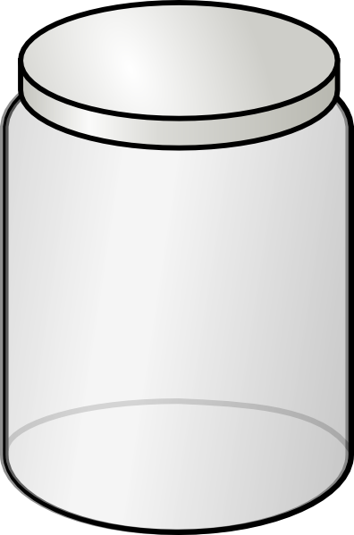

*****PLEASE DO NOT WRITE ON THIS PAPER!!!*****
(Draw the correct picture for each state of matter)
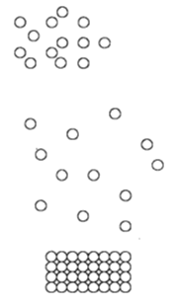
Definite shape
Definite volume (x2)
Takes shape of container
Fills container
No definite volume
Particles spread very far apart
Particles little far apart
Particles very close together
Particles vibrating
Particles slide past one another
Particles moving very fast
Sublimation
Vaporization
Freezing
Melting
Condensation
Deposition
Temperature highest
Temperature lowest

