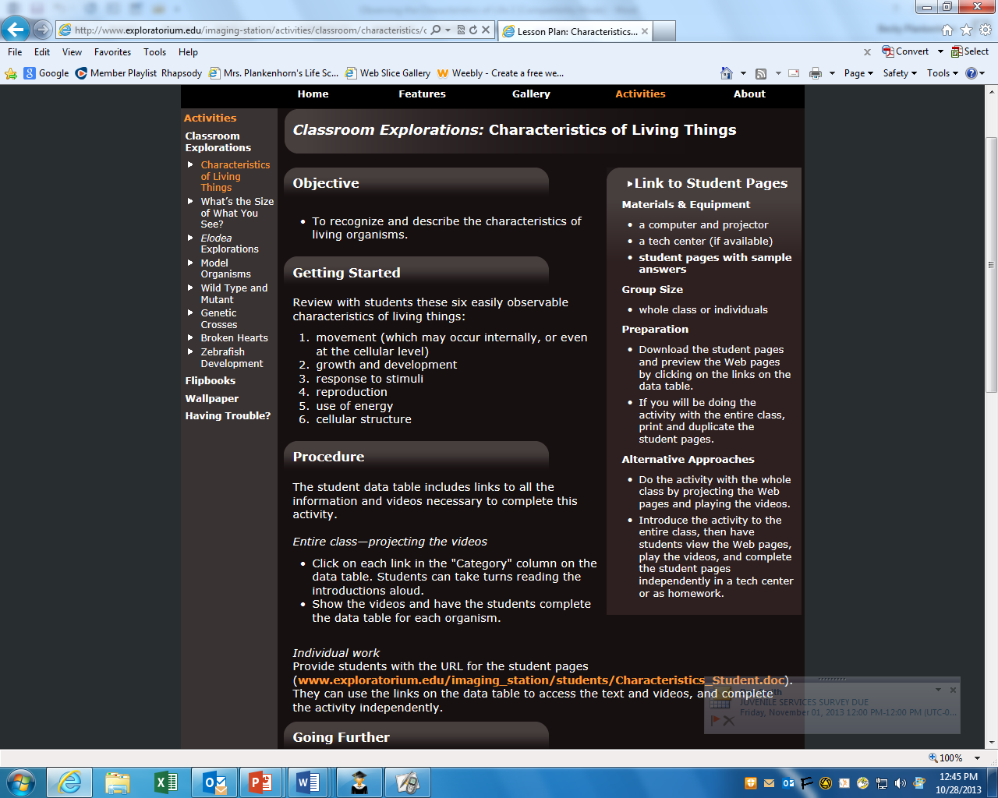
DO NOT WRITE ON THIS!
DO NOT TAKE THIS!
iPad Exploratorium Observing the Characteristics of Life LAB
1. Go to Plankenhorn Weebly Web site, Links, Exploratorium Microscope Imaging Station.

2. Write down these characteristics of living things on your paper: #1-#6

3. Answer the next two questions on your paper: “What characterisitc did this site not mention that
we are learning as one of the charateristics of living things (from our text book) AND what one
characteristic does this web site list that our textbook does NOT list.

4. Click on this link.

5. Now scroll down to page two—“Characteristics of Life Data Table”

6. Click on the blue words C. elegans and this will take you to a video.
Read the information about that organism.
Now click and play the video.
Record on your paper the Characteristics of Life that you observe and write a Description of
the Observed Characteristics.

7. Repeat Step #6 for each video.

8. IF YOU HAVE COMPLETED THE WORKSHEET, YOU MAY go back to the Microscope Imaging Station and click and explore any of these pages: Features, Gallery, Activities

