A. _________esophagus____________  B. G. I________________________ ______  C. __________________________________  D. __________________________________  E. L. ________________________________  F. __________________________________  H. __________________________________  J. __________________________________  K. __________________________________  M. __________________________________  N. ________artery____________________  P. __ | Name ____________________________________  Period _____Date___________________________  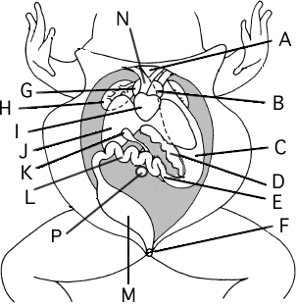
LABEL THE DIAGRAM
I CAN describe and identify structures and functions of an amphibian.

