Name ________________________
Date ___________________P. ____

THE HUMAN BRAIN NOTES

Your brain is your most powerful organ, yet weighs only about three pounds. It has a texture similar to firm jelly.
1. Label the three main parts of the brain.
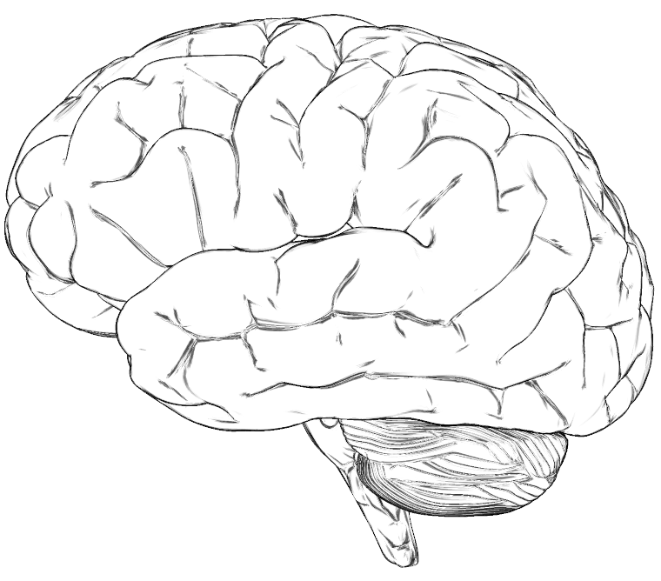

2. The part of the brain that controls vision, thinking, hearing, remembering, problem solving, thinking and feeling is called the

3. The part of the brain that controls balance, coordination—muscle memory for skills such as skating, walking, golfing, or throwing is called the

4. The part of the brain that controls automatic functions such as breathing, digestion, heart rate and blood pressure is called the

Name ______________ Period _____

Study of the Frog's Brain
Starting at the most anterior part of the head, the olfactory nerves connect to the nostrils and then to the olfactory lobes (A) where odors are processed. Just posterior to the olfactory lobes are two elongate bodies with rounded bases, this is the cerebrum (B), and it is the frog's thinking center. The cerebrum is the part of the brain that helps the frog respond to its environment. Posterior to the cerebrum are the optic lobes (C), which function in vision. The ridge just behind the optic lobes is the cerebellum (D), it is used to coordinate the frog's muscles and maintain balance. Posterior to the cerebellum is the medulla oblongata (E) controls involuntary actions of organs and connects the brain to the spinal cord (F).
COMPLETE THE CHART.
Brain Part Function Letter  Cerebellum  Cerebrum  Olfactory Lobe  Optic Lobe  Medulla Oblongata | 