Name __________________________________
Period____Date__________________________

HOW DOES ENERGY MOVE THROUGH A FOOD WEB?

All organisms need energy to live. Organisms get energy by eating food. Energy passes through an ecosystem. Producers are organisms that make their own food. Consumers are organisms that get energy by eating other organisms.

Use the picture below to answer these questions.

1. What does the squirrel eat for energy?______________________________________
2. Which animal eats both plants and animals?_________________________________
3. How does energy pass from plants to the spotted owl?________________________
_______________________________________________________________________
4. What are the producers in the food web?____________________________________
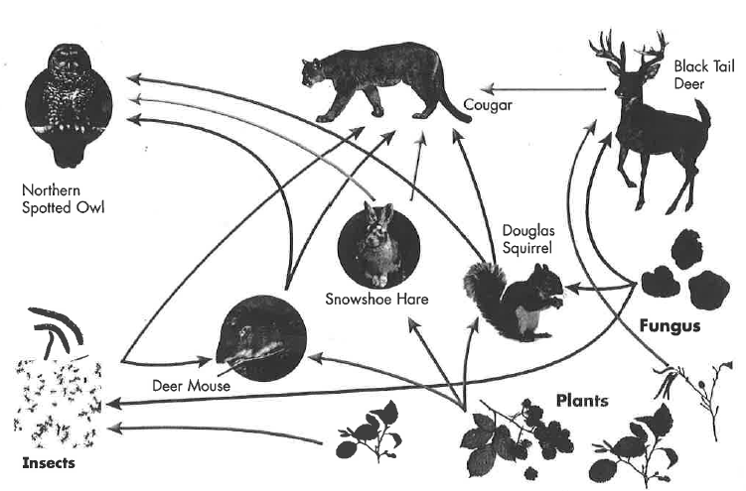

Turn your paper over and draw a Redwood Tree Canopy Food Chain/Web.
Read the directions on the colored information paper titled--
“Life in a Redwood Tree Canopy.”

