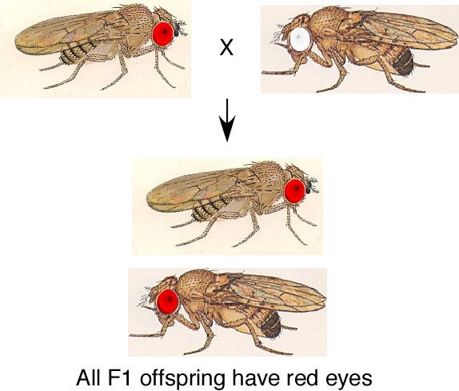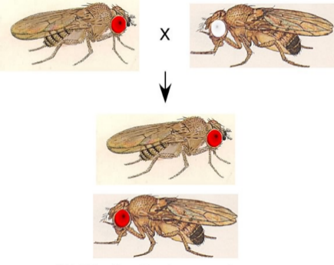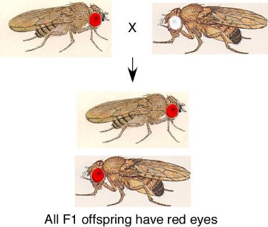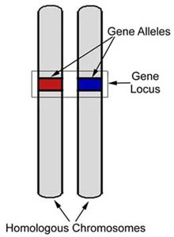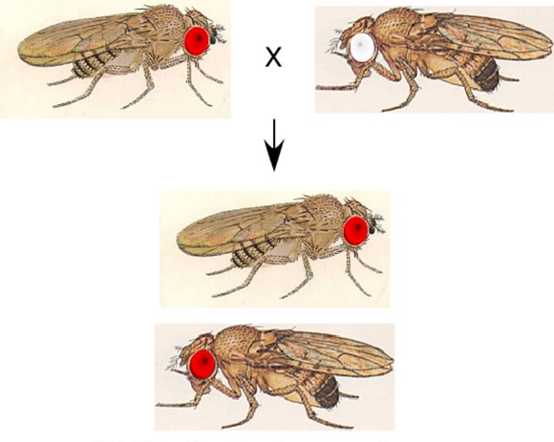

In fruit flies, the allele for red eyes (_***R***__) is ***dominant***

* The genotype of this fly would be

Rr or RR

**Each parent has two alleles but only passes one on to its offspring. *Random***

***chance* determines which of the two alleles is passed on.**

***TWO*** alleles for the eye color gene

Dad passes on ***ONE***

of his alleles for the gene

Mom passes on ***ONE***

of her alleles for the gene

Mom

***TWO*** alleles for the eye color gene

In fruit flies, the allele for white eyes (_*r*__) is ***recessive***

* The ***genotype*** of this fly can only be rr

The ***offspring*** gets two   
copies (two ***alleles*** for each gene, one from each parent.

Dad

**If the offspring has two different *alleles* for the same gene, what determines which trait is *expressed*, or shown? *The one that is dominant.***