Name ___________________________________

P._____Date_____________________________

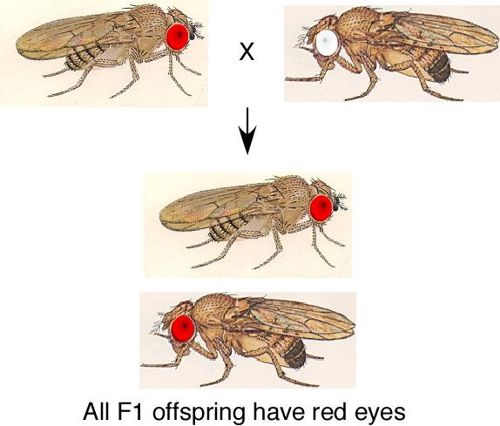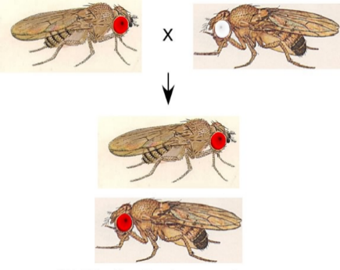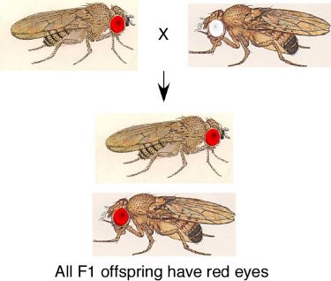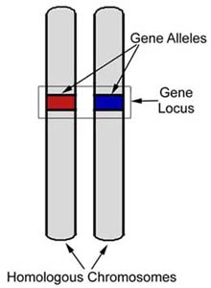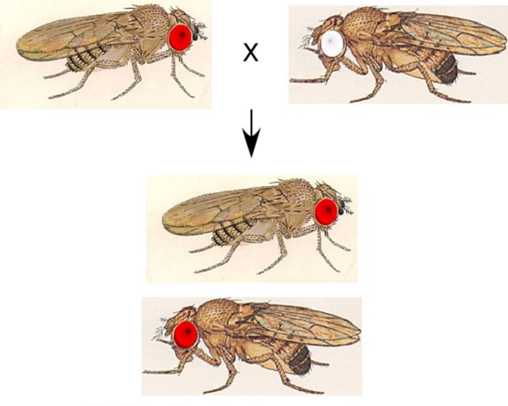

**If the offspring has two different ___________________for the same gene, what determines which trait is *expressed*, or shown?___________________**

In fruit flies, the allele for red eyes (____) is _________________

* The _________________________ of this fly would be

Rr or RR

**Each parent has two alleles but only passes one on to its offspring. ________________ ________________ determines which of the two alleles is passed on.**

____ alleles for the eye color gene

Dad passes on _____

of his alleles for the gene

Mom passes on _____

of her alleles for the gene

Mom

_____alleles for the eye color gene

In fruit flies, the allele for white eyes (____) is __________________

* The _________________________of this fly can only be rr

The _______________________ gets two   
copies (two _______________) for each gene, one from each parent.

Dad