Name __________________________________
I CAN compare types of cells and describe the discovery of cells.
Period _____Date_________________________

Giant Amoeba Eats New York City TRUE or FALSE?
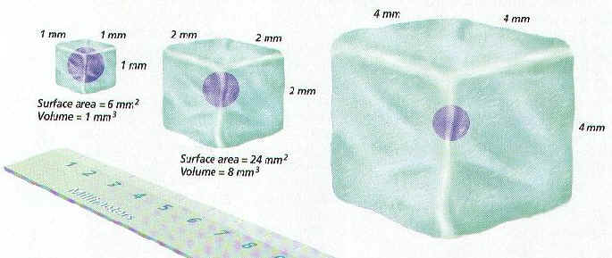

A small cell (above left) has a larger surface-area to volume ratio that a bigger cell (center.) As a cell get larger, it needs more food and produces more waste. Therefore, more materials must be able to move into and out of the cell through the cell membrane. To keep up with these demands, a growing cell needs a larger surface area through which to exchange materials. As the cell’s volume increases, the outer surface grows too. But the volume of a cell (the amount a cell will hold) increases at a faster rate than the area of its outer surface. If a cell gets too large, its surface will have too few openings to allow enough materials into and out of it.

Imagine cells as little cube blocks. A small cube cell is one unit in length.

The total surface area of this cell is calculated by the equation:
height × width × number of sides
1 × 1 × 6 ×= 6 mm²
The volume of the cell is calculated:
height x width x length
1 × 1 × 1 = 1 mm ³
**(2 x 3) x 2 + (4 x 3) x 2 + 4 x 2) x 2 = surface area

1. Complete the following table.

Dimensions of Cell | Surface Area  (each cell has 6 sides) | Volume | Surface Area to Volume Ratio
1 mm x 1 mm x 1 mm | 6 mm² | 1 mm ³ | 6:1
2 mm x 2 mm x 2 mm | 24 | 8 mm ³ | 3:1
3 mm x 3 mm x 3 mm | 54 mm² | 27 | 2:1
5 mm x 5 mm x 5 mm | 150 mm² | 125 mm³ | 1.2:1
**2 mm x 3 mm x 4 mm | 52mm² | 24 mm³ | 2.2:1

Circle the correct answer for #1-5 below.

2. A smaller cell has a greater surface area to volume ratio than a larger cell. True or False

3. As a cell grows in size, the volume of its cytoplasm increases at a slower
rate than the surface area of its cell membrane. True or False

4. As the volume of a cell’s cytoplasm increases, its plasma membrane
becomes too small to absorb the amount of nutrients the growing cell
requires or excrete the increasing amount of waste it produces. True or False

5. A cell can grow as large as it wants, as long as its environment
provides enough nutrients. True or False

An increased surface area to volume ratio means increased exposure to the environment. This means that nutrients and gases can move in and out of a small cell more easily than in and out of a larger cell.
The smallest prokaryotic cell currently known has a diameter of only 400 nm. Eukaryotic cells normally range between 1– 100 µm in diameter.
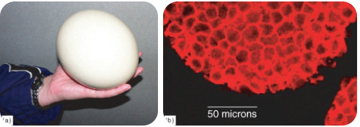
Ostrich eggs (a) can weigh as much as 1.5 kg, and be 13 cm in diameter, whereas each of the mouse cells (b) shown at right are each about 10 µm.
The cells you have learned about so far are tinier than the period at the end of this sentence, so they are normally measured on a very tiny scale. Most cells are between 1 and 100 µm in diameter. The mouse cells in Figure above are about 10 µm in diameter. One exception however, is eggs. Eggs contain the largest known single cell, and the ostrich egg is the largest of them all. The ostrich egg in Figure above is over 10,000 times larger than the mouse cell.

Refer to pages 22-23 in your textbook.

6. How many centimeters in a meter? 100

7. How many millimeter in a meter? ____1000__________________

8. What does the unit µm mean? ________micrometers also called microns________

9. How many µm are there in a millimeter? 1000

10. What does the unit nm mean? nanometer

11. How many nm are in one micrometer? 1000

